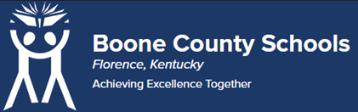
Boone County Board of Education Members
Mrs. Karen Byrd, Board Chair
Mr. Jesse Parks, Vice Chair
Dr. Maria Brown
Mrs. Carolyn Wolfe
Mrs. Cindy Young

Mr. Matthew Turner, Superintendent

Board Memo

DATE: 5/9/2023

AGENDA ITEM DETAILS:
School/Department
Learning Support Services (NHES)
Product Vendor or Grant Issuer
Imagine Learning
Product or Grant Name
EL Education
Date/Term (Beginning and End Dates/Year)
August 1, 2023, to July 1, 2024

APPLICABLE BOARD POLICY:
N/A

DESCRIBE USE OF CONTRACT/PURCHASE/AGREEMENT
Comprehensive, core language arts program in which students focus on mastery of knowledge and skills. Strategic Plan Connection – Goal 1: World Class Education. “Boone County Schools will ensure all students will receive rigorous and engaging instruction” (1B)

FUNDING FOR PURCHASES AND OTHER REQUESTS:
Total Cost
$82,001.67

Funding Source
SBDM (General Funds) & ESSER

*If more than one funding source, list below along with amount or percent for each source

IF THIS IS A GRANT, ENTER AMOUNT TO BE AWARDED:
SBDM - $39,255.92, ESSER - $45,125.84

RECOMMENDATION:
I recommend that the board approve this agreement as presented.

Dr. Jim Detwiler, Deputy Superintendent/CAO

CONTACT PERSON:
Julie Rubemeyer, Director of Elementary Teaching and Learning

