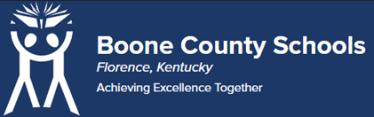
Boone County Board of Education Members
Mrs. Karen Byrd, Board Chair
Mr. Jesse Parks, Vice Chair
Dr. Maria Brown
Mrs. Carolyn Wolfe
Mrs. Cindy Young

Mr. Matthew Turner, Superintendent

Board Memo

DATE: 4/24/2023

AGENDA ITEM DETAILS:
School/Department
Ignite Institute
Product Vendor or Grant Issuer
Covington Independent Schools
Product or Grant Name
MOU with Covington Independent Schools and Boone County Schools
Date/Term (Beginning and End Dates/Year)
07/01/2023 – 06/30/2024

APPLICABLE BOARD POLICY:
N/A

DESCRIBE USE OF CONTRACT/PURCHASE/AGREEMENT:
This MOU is the agreement between Covington Independent Schools and Boone County Schools regarding the Ignite Institute. This MOU outlines the parameters for attendance, curriculum, financial obligations for regional schools who have students in attendance at Ignite. Strategic Plan Connection – Goal 3: Stakeholder Engagement. “Boone County Schools will increase and expand community and business partnerships” (3B)
FUNDING FOR PURCHASES AND OTHER REQUESTS:
Total Cost
N/A
Funding Source
N/A
*If more than one funding source, list below along with amount or percent for each source

IF THIS IS A GRANT, ENTER AMOUNT TO BE AWARDED:
N/A

RECOMMENDATION:
I recommend that the board approve this memorandum of understanding as presented.

Dr. Jim Detwiler, Deputy Superintendent/CAO

CONTACT PERSON:
Bill Hogan, Director of Innovative Programs

