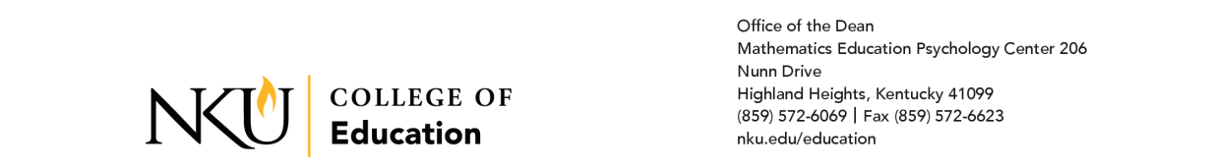

From: Dr. Ginni Fair, Dean, College of Education
RE: Option 9 Agreement
Date: April 22, 2023

Memorandum of Agreement
NKU Partnership with Northern Kentucky Cooperative for Educational Services

The Northern Kentucky University College of Education would like partner with NKCES districts to provide expedited Kentucky teacher certification to participants, pursuant to House Bill (HB) 277, which amended KRS 161.048 to create Option 9.

The participant teachers from NKCES districts will complete a bachelor’s degree and initial certification in a three-year period while working in a non-teaching position in a school district.

A cohort of at least 20 students within the regional districts will allow NKU’s College of Education to offer a cohort-model option that offers program courses in sequences and formats that meets the needs of its unique participants. To be eligible for this Option 9 route, participants must be employed by a school district within the NKCES region.

Respectfully submitted for your consideration,

Dr. Ginni Fair
Dean, College of Education
Northern Kentucky University
Fairg1@nku.edu

Responsibilities of NKU:

- NKU will advise participants on which classes to take in which semester.
- NKU will offer classes in formats that are appropriate for the unique population of Option 9 students (online, in summer/winter institutes, on evenings or weekends).
- NKU will follow EPSB guidelines for admission to an undergraduate, initial certification educator preparation program [16 KAR 5:020, Section 1(2).
- NKU will utilize work experience settings for fulfillment of student teaching expectations. (NKU may recommend, however, that participants teach or work in slightly varied settings, depending upon certification areas.)
- NKU will assign a university supervisor to work with the participant during the third year of the program.

Responsibilities of Participating NKCES School Districts:

- Employ the participant in a residency or paraprofessional program within the school district for the duration of the program as long as the participant is making successful progress in the Option Nine program;
- Utilize experienced teachers employed by the district to provide coaching and mentoring to the participant;
- Ensure at least one mentor is certified in the area in which certification is being sought;
- Ensure the availability of funding for each participant for the duration of the candidate’s participation in the program as long as the participant is making successful progress in the Option Nine program;
- Ensure at least one (1) year of employment provides hands-on experience in the area in which certification is being sought; and
- Continue this partnership until the district’s employed participants for Option 9 certification complete the program or are no longer employed by the district.
Responsibilities of Participants:

- Participants must apply to NKU as an undergraduate student.
- Participants must meet admission requirements as established by EPSB in 16 KAR 5:020, Section 1(2).
- Participants are responsible for paying all fees charged by NKU other than tuition.
- Participants will be responsible for completing any state requirements necessary for certification in their program area(s).

________________________________ _____
Dr. Matt Cecil Date
Provost & Executive Vice President of Academic Affairs, NKU

________________________________ _____
Dr. Ginni Fair Date
Dean, NKU College of Education

________________________________ _____
___________________ (Printed Name) Date
____________________________________ (Title)

