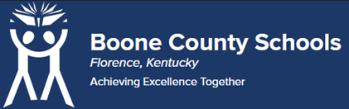
Boone County Board of Education Members
Mrs. Karen Byrd, Board Chair
Mr. Jesse Parks, Vice Chair
Dr. Maria Brown
Mrs. Carolyn Wolfe
Mrs. Cindy Young

Mr. Matthew Turner, Superintendent

Board Memo

DATE: 5/3/2023

AGENDA ITEM DETAILS:
School/Department
Boone County Schools
Product Vendor or Grant Issuer
Northern Kentucky University
Product or Grant Name
NKU Partnership with Boone County Schools/ESL Certification Cohort
Date/Term (Beginning and End Dates/Year)
August 2023 to December 2024

APPLICABLE BOARD POLICY:
N/A

DESCRIBE USE OF CONTRACT/PURCHASE/AGREEMENT
Memorandum of Agreement between Northern Kentucky University and Boone County Schools. This is an agreement to provide graduate training to Boone County Teachers in English as a Second Language (ESL).

FUNDING FOR PURCHASES AND OTHER REQUESTS:
Total Cost
Will not exceed $60,000.00

Funding Source
EL Budget – General Fund

*If more than one funding source, list below along with amount or percent for each source

IF THIS IS A GRANT, ENTER AMOUNT TO BE AWARDED:
N/A

RECOMMENDATION:
I recommend that the board approve this memorandum of agreement as presented.

Dr. Jim Detwiler, Deputy Superintendent/CAO

CONTACT PERSON:
Dr. Genine Piche, Director of Language Learners

