
Communication Updates- February 2023
Candace Gibson- Communication and Outreach Coordinator

NEWSLETTER
I have recently received a notification from Mailchimp that their free service will now only allow for a maximum of 1,000 mail sends per month. I will no longer be able to send a weekly newsletter to all of our subscribers under the plan. The upgrade will cost $156/year. I am researching other newsletter services (specifically those that are focused on education) to ensure that, if we must now put financial investment into a newsletter service, we are providing the best product for our families.
MAILCHIMP- NEWSLETTER IMPACT (based on the latest edition)
Total Subscribers | 318
Number of subscribers who engage via email | 138 opens, 6 link clicks
Social media impressions per week | Facebook- 441 (12 engagements)  Twitter- 93 (10 engagements)

SOCIAL MEDIA
This month social media activity included the launch of our Open Enrollment marketing, as well as Kindergarten Registration info. The goal during this enrollment period is to focus on 2 posts per day that specifically highlight images of students and student work to give a glimpse of what’s happening in our classrooms. Below are the top performing posts of the month.
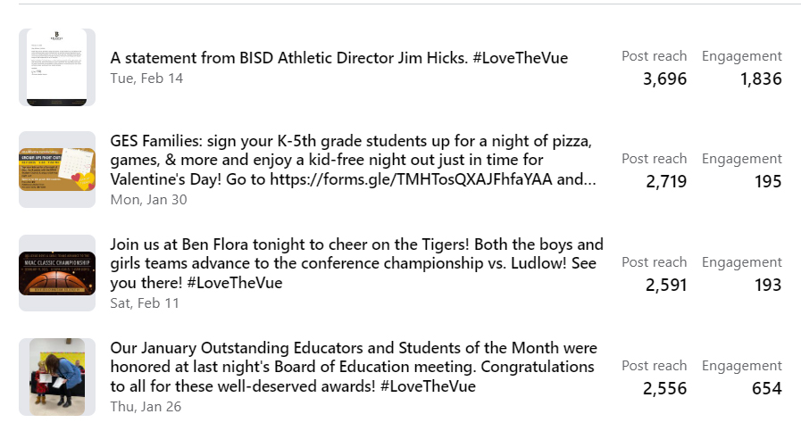
FACEBOOK MONTHLY IMPACT
Total post reach this month | 16,103
Total post engagement (likes, comments, etc) | 12,863 (doubled from last month!)
Number of posts this month | 64
New followers; new page likes | +29; +13
Total shares | 157

NEW DESIGN PROJECTS
The designs for the rollout of our new Mission & Vision, Strategic Plan, and Portrait of a Graduate are underway. These projects are the majority of my focus through the beginning of March. Additionally, I am working with Athena Hall on unique branding to promote the new I3 program.
WEBSITE UPDATES
Images have been updated throughout our website, and our home page has had a few layout modifications to simplify the delivery of information. I will be taking advantage of webinars to help me get a handle on some of the more complex features of our website composer system.

