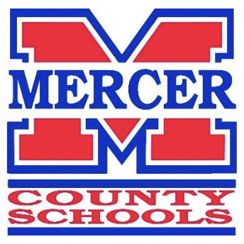
PROFESSIONAL GROWTH PLAN (PGP)
2021-22

____Jason Booher______________ _____Mercer County___________
Name District

_____________________________________ ________________________________
Board Initial Approval Date Board Completion Date

While it is understood that the Superintendent will be evaluated on all seven standards, the Professional Growth Plan (PGP) provides an opportunity to narrow the focus and provide greater depth. During the 2021-2022 school year, the Superintendent will focus on the following Standard(s) in the PGP.

Standard and Goal | Actions that Demonstrate the Standard | Evidence/Artifacts | Dates Initiated/Completed
Standard 6  Collaborative Leadership:  The superintendent, in concert with the local board of education, designs structures and processes that result in broad community engagement with support for and ownership of the district vision. Acknowledging that strong schools build strong communities, the superintendent proactively creates, with school and district staff, opportunities for parents, community members, government leaders, and business representatives to participate with their investments of resources, assistance, and goodwill. | - Develop Local Business partnerships  - Participate in local community organizations (ex. Rotary)  - Participate in Community Speaking Engagements  - Increase Media Coverage of School and District Accomplishments  - Attend local government meetings  - Develop partnership with local ATC and College  - Work with local media to promote Mercer County School system, schools, staff, and students | 1a. Whitaker Bank partnership to purchase new football scoreboards for high school and middle school. $28,000  1b. Partnered with Kentucky Farm Bureau to have them sponsor purchasing all Mercer County student’s regular season home athletic even tickets. No student pays anymore. $8,000  3a. Shared personal testimony with entire staff at opening day.  6a. Met with principal of Trailblazers, David Christopher to discuss vocational school program and what they offer our students | 1a. August 2, 2021  1b. August 10, 2021  3a. August 9, 2021  6a. July 19, 2021

Standard 6: Collaborative Leadership

SUMMARY: The superintendent, in concert with the local board of education, designs structures and processes that result in broad community engagement with support for and ownership of the district vision. Acknowledging that strong schools build strong communities, the superintendent proactively creates, with school and district staff, opportunities for parents, community members, government leaders, and business representatives to participate with their investments of resources, assistance, and goodwill.

PRACTICES (Indicators):
Collaborating with and responding to diverse communities. The superintendent…

a. Develops collaborative partnerships with the greater community to support the 21st century learning priorities of the school district and its schools Vision/High Expectations

b. Ensures systems that engage the local board and all community stakeholders in a shared responsibility for achieving district goals for students and school success Stakeholder/Community Involvement

c. Implements proactive partnerships with community colleges, universities, professional organizations, educational cooperatives, and/or other key professional development organizations to provide effective professional learning opportunities Professional Learning/Stakeholder Involvement

d. Implements proactive partnerships that remove barriers thus ensuring all students have access to college and career courses in high school Stakeholder Involvement

