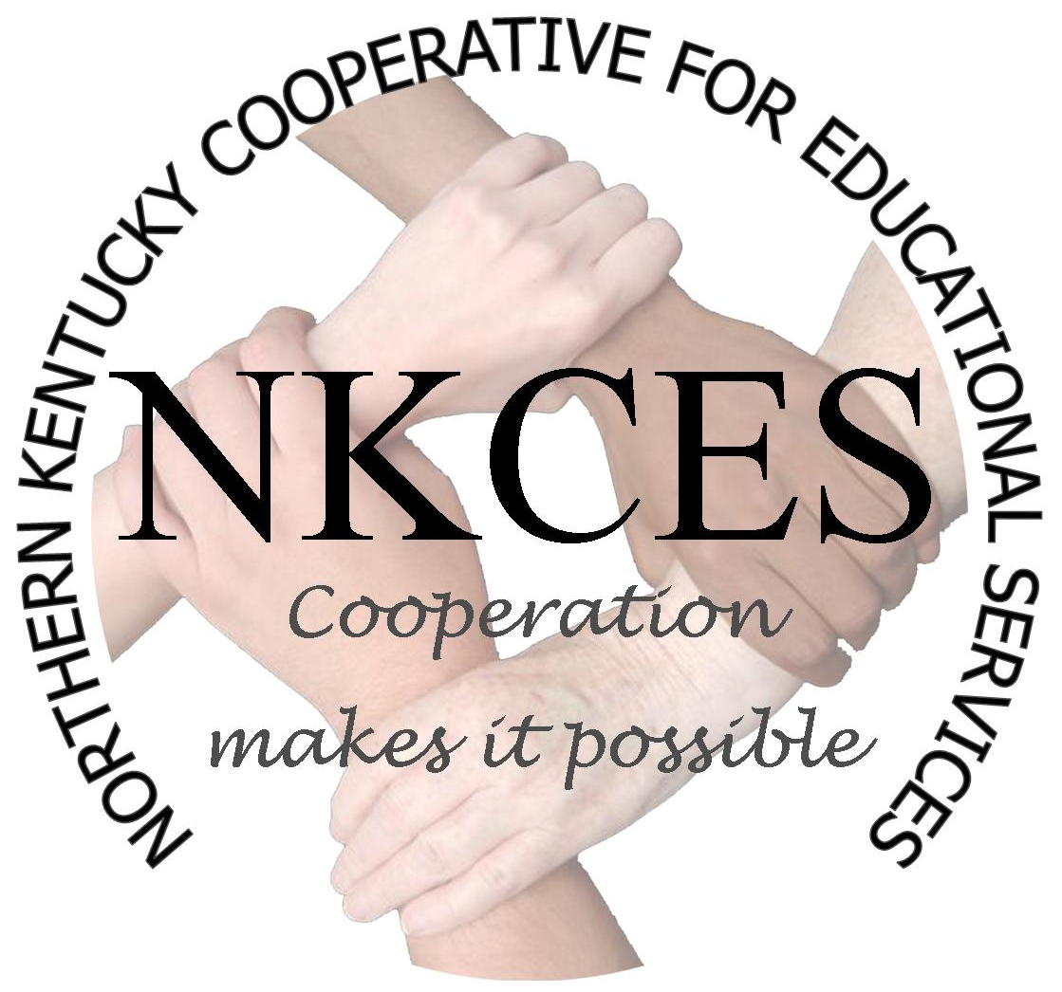
Northern Kentucky Cooperative for Educational Services, Inc.
Member Districts
Beechwood Independent • Bellevue Independent • Boone County • Bracken County
Campbell County • Covington Independent
Dayton Independent • Erlanger-Elsmere Independent • Ft. Thomas Independent
Gateway Community and Technical College • Kenton County
Ludlow Independent • Newport Independent • Northern Kentucky University • Pendleton County
Silver Grove Independent • Southgate Independent • Walton-Verona Independent • Williamstown Independent

Executive Director’s Report – June 2015

NKCES meets with State Board Members

Several members of the NKCES Board of Directors met with State Board of Education members Nawanna Privett and Leo Calderon to discuss desired characteristics of the next Commissioner of Education. The dialog with the Board members was very positive. A summary of comments shared during the meeting are attached to Board materials for the June Meeting of the Board of Directors.

NKCES Facility Update

As voted by the Board of Directors during the May Board of Directors meeting, the areas of concern with the facility located at 5516 East Alexandria Pike are being addressed by Houston Brothers, Inc. The medallion located above the main entrance is being taken down and removed to a location on site. In future months, the new Executive Director will begin the process of exploration of the sale of the property located at 5516 East Alexandria Pike. In addition, Mr. Matt Compton, Principal of the Regional School Programs has been notified of working during the upcoming year to determine a new location for the Regional School Programs for the 2016-2017 school year.

NKCES Webpage Revision

NKCES has contracted with Five Oaks Communications, LLC (Armando Arrastia) to revise and develop a new image of NKCES via our organization webpage. Feedback concerning the current format and image of the NKCES webpage has not met our desired expectations of being user friendly and relevant for our meeting our district needs. An anticipated launch date of August 1st has been proposed. Multiple meetings have taken place to provide feedback and input to Mr. Arrastia as expectations for our website. Training for the migration of content for all of the personnel at NKCES is scheduled for the middle of June.

In addition, we are in the process of exploring the continuation of legally functioning as the “Northern Kentucky Cooperative for Educational Services” while we could potentially do business as “Northern Kentucky Education Cooperative.” This streamlines our business title and will be reflected in a new logo.

We are excited about the new future opportunities to serve our districts and our region.

Professional Learning Opportunities for Summer and Early Fall 2015

The table listed below represents the numerous opportunities for professional learning for teachers and administrators.

Topic | Dates (Times) | Location
KASA Regional PGES Roundtables (Register with Alissa Aryes or Brian Vanover) | June 9 | Randall Cooper High School
Next Gen Science Standards (Register with Hallie Booth) | June 11-12 (8:30-4:00) | Erlanger-Elmere Ind. School District
KY Behavior Institute | June 17-18, 2015 | KY International Convention Center
Para Educator Conference | June 22-25 (Choose One day)  (8:00-3:30) | Ralph Rush Center
Orton Gillingham (Advanced Training) | June 22-25 (8:00-3:30) | Gateway Convening Center Boone County
2015 Ready Kids NKY Conference (Contact Julie Goodpaster; 502-839-2513) | June 23-24 (8:00-3:30) | The METS Center
NKY Principal PGES | June 24 (TPGES – Special Education (8:30-11:30); Instructional Coaches (12:30-3:30) | NKCES PD Center
Juvenile Justice Reform Training | June 29 | Gateway Community and Technical College Boone County
CBB Module – Algebraic Thinking Grades 6-8 | July 7-8 | NKCES PD Center
Alternate K-Prep Science | July 8 | NKCES 2nd Floor Conference Room
KY Peer Support Network Summer Training | July 14 | TBA
CBB Module – Ratio and Proportionality | July 14-15 | NKCES PD Center
The Flipped Classroom | July 15-16 | NKU
CBB Module – Geometry | July 21-22 | NKCES PD Center
Teaching Academic Content and Literacy to English Learners | July 22 | The METS Center
Orton Gillingham (Basic Training) | July 20-24 | Gateway Community and Technical College (Boone County)
Standards Based Grading and Reporting; Dr. Tom Gusky | July 27 | Dietz Auditorium (Erlanger ISD)
Differentiation | August TBA | NKCES PD Center
IEP for new teachers and staff | August 13 | NKCES PD Center
Coaching Classroom Management | September 22-23 | Gateway Community and Technical College Boone County

2015-2016 Content Leadership Networks

KDE is sponsoring the Content Leadership Networks for the 2015-2016 school year. This will continue to be an opportunity to support teacher leaders in Science and Social Studies. District Administrators have been provided a form to indicate representatives from districts/schools for each network. In addition, the dates for the meetings are listed below.
ISLN Science CLN Social Studies CLN
Sept. 18 Sept 21 Sept. 28
Oct 16 Oct 19 Oct 26
Nov 20 Nov 23 Nov 30
Jan 22 Jan 25 Jan 29
Feb 19 Feb 22 Feb 29
Mar 18 Mar 21 Mar 28

