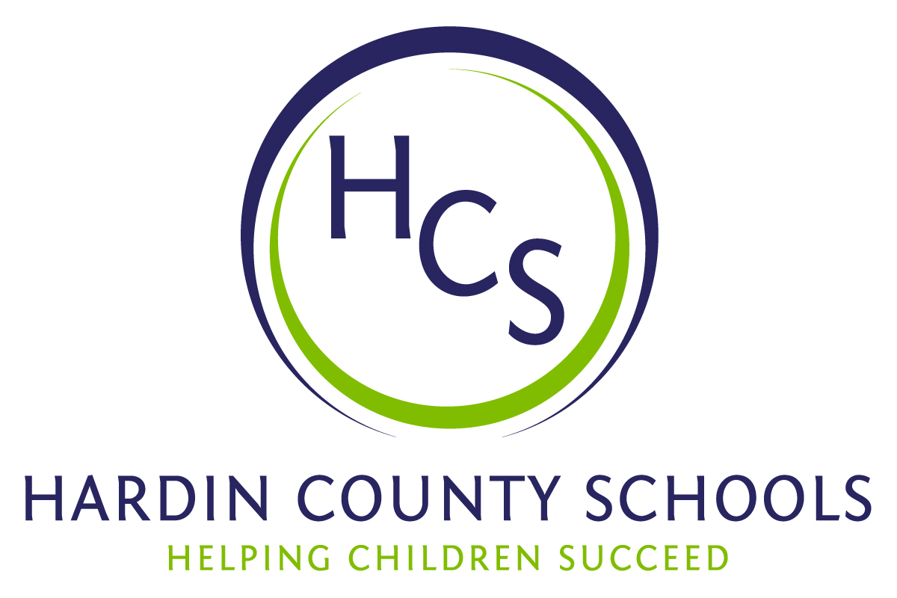

Associate Superintendents
Mark Kopp, Instructional Services
Bobby Lewis, Student Services
Gary Milby, Finance/Support Services
Chris Reed, Human Resources

Board of Education
Charlie Wise, Chair
Kay Sharon, Vice Chair
Suzy Broadwater
John Emary
Mike Kinney

Nannette Johnston, Superintendent

Resolution of Recognition

WHEREAS, the function of a Board of Education is to strive for excellence in all phases of educational programs, and;

WHEREAS, a major indication of such excellence is awards and honors earned by the students, employees and programs of the school system, and;

WHEREAS, the Hardin County Board of Education deems it fitting and proper that significant awards and honors be recognized by the Board;

BE IT THEREFORE RESOLVED THAT the Hardin County Board of Education, meeting in regular session on January 15, 2015, does hereby recognize the achievements of the following:

Susan Sherrard, a Central Hardin High School English and Journalism teacher, has earned National Board Certified Teacher status.
Central Hardin High School students Garrett Kasey & Emma Riney were elected Speaker of the House and Outstanding Delegate, respectively, at the Kentucky Youth Assembly. Jeff Crady is the CHHS KYA Sponsor.
John Hardin High School student Ethan George won an Outstanding Congressional Delegate award at the Kentucky Youth Assembly. Jan O’Daniel and Becky Lanham are the JHHS KYA Sponsors.
The John Hardin High School JROTC Marksmanship Team earned first place at the Kentucky State Air Rifle Championships. The State Championship Team consisted of Ethan George, Maricel Kulti, Michael Bentley, and Sage Layson. The Championship Team scored 2028 points out of a possible 2400 points. Ethan George also took the individual State Championship with a score of 527 out of 600 possible points. This is the second consecutive year that a group from the JHHS JROTC has won the State Team Championship and the second consecutive year that the Individual State Champion has come from John Hardin High School. JHHS JROTC advisors are: Lt. Colonel Warren Griggs and Sgt. Major Rob Robinson
John Hardin High School All-State Band Members
Kody Brown
Connor Mitchell
Matthew Robinson
Band Director: Brian Ellis

John Hardin High School All-State Chorus
Jessica Brandt
Holden Wiggins
Chorus Director: Phyllis Westfall

North Hardin High School All-State Jazz Band
Zach Ayer
Josh Edwards
Band Director: Brian Froedge

North Hardin High School All-State Orchestra
Misaki Hall
Band Director: Brian Froedge

The North Middle School Kentucky Youth Assembly students earned Delegation of Distinction status.
Zaire Garrido
Kiara Jackson
Cody Justice
Dynasti Ligon – Outstanding Delegate
Nevaeh Marshall
Malcolm Matzdorff
Chanelle McLean
Quynshon Mitchell
Kristyonna Starry
Sponsors: Kayla Berg and Derrick Bunnell

Central Hardin High School All-State Choir

Jacob Breeding
Paul Brosky
Chloe Brown
Allison Conder
Nick Cox
Spencer Floyd
Mathew Gaudern
Kyle Gordon
Brianna Harris
Kaitlyn Jaggers
Olivia Kaelin
Mark McLean
Mitchel Saget
Isabella Singer
Karina Shoaf
Risa Tomioka

Choir Director: Brandon Centers

Central Hardin High School students that earned KHSAA Academic All-State status:

Samantha Bell
Madalaine Benedetti
Eli Best
Alex Bibb
Brittany Brangers
Emily Brown
Matthew Brewer
Jessi Bunch
Alec Burgess
Emily Chandler
Amelia Cox
Rachel Coleman
Carly Dyrdek
Conner Elmore
Grace Flanagan
Whitney Frank
Caitlin Gage
McKinley Grenier
Cody Hall
Hadley Handel
Noah Harrub
Aaron Hashemi
Meredith Jones
Taylor King
Garrett Kasey
Erin Kelley
Brittany Lowe
Wesley McCoy
Rachel Mobley
Rebekah Mobley
Aubree Muse
Evan Newton
Sarah Nichols
Samantha Norris
Kayla Nunn
Mary Osborne
Emma Pike
Allison Powers
Keara Priddy
Michael Quire
Patrick Quire
Rachel Rivera
Andrew Schmit
Seth Serreff
Chloe Sheeran
Jordan Smith
Samuel Smith
Austin Stevens
Ben West

John Hardin High School students that earned KHSAA Academic All-State status:

Kelly Ahearne
Salvatore Anzola
Kaitlyn Arel
Abdallah Atiyani
Connor Barclay
Taylor Bell
Michael Bentley
Raliegh Boulware
Hunter Boza
Carlitta Brown
Mason Bryant
Miranda Buccola
Tyler Caccamo
Morgan Cain
Hunter Campbell
Korie Cleveland
Eric Corneilson
JR Covarrubias
Jessica Crittenden
Chase Croley
Hunter Deno
Nathaniel Diaz
Brinley Drexler
Tatum Feiler
Hosana Fitzgerald
Regan Fleming
Ricki Flora
Ryan Gann
Ethan George
Cullen Green
Sam Herringshaw
David Howey
Brandon Hubert
Brandon Hustead
Dreyk Inman
Rylan Jaquess
Hannah Javier
Trent Johnson
Olivia Kohler
Paul Kotarski
Selina Krieg
Ezra Largent
Connor Lewis
Lucca Mazzarato
Emily McIntyre
Kelly McTaggart
Andrew Minnis
Austin Mixon
Hannah Mosley
Hannah Munoz
Kyah Neal
Carson O'Daniel
Cheyanne Robinson
Courtney Shader
Tyler Skees
Keeley Slade
Elayna Snyder
TJ Stuart

North Hardin High School students that earned KHSAA Academic All-State status:

Sam Carter
Hannah Corbin
Emily DeRosa
Brandon Dulaney
Molly Emdee
Hannah Harden
Ian Hayward
Chris Heinrich
Mitchel Johnson
Emily Laws
Miguel Luna
Brooke Mahanna
Martin Marlin
Brooke Marlow
Hunter Maxwell
Geoff Nelson
Amanda Patterson
Faith Peet
Robert Rupp
Ashley Sheetz
Noah Stevens
Christian Stover
Madison Teeter
Austin Torres
Elijah Wall
Ben Wilkins
Sarah Wiseman

The John Hardin High School Football team reached the semifinals of the 5-A KHSAA Championships. The Bulldogs have won seven consecutive football regional titles.

Antonio Ayers
Mykel Bailey
Corey Barnes
Devin Bates
Jared Buchert
Brett Buckout
Hunter Campbell
Jaylen Carter
Justin Carter
Paysore Casey
Ethan Cobb
Korie Cleveland
Chyl Crenshaw
Jerome Dingle
Cameron Doss
Chris Evans
Ryan Gann
Jared Givan
Marquell Green
Devonte Guillory
Brian Halchishick
TJ Hamm
Tommy Harper
Brody Haverstick
CJ Hill
Dylan Howard
Kendrick Johnson
Stephen Kaiser
Darion Keener
Christian Keese
Alex Lake
Steven Livers
Andric Lundsford
Niko Llyod
Thomas Llyod
Tyler Marsh
Mailk McGregor
Josh Miller
Austin Mixon
Dwayne Mollison
Juwain Mollison
Maleek Moody
Tyree Moody
RJ Mooring
EJ Piernas
Anthony Polite
Dakota Prichard
Thomas Rogers
Robert Shorter
Zion Smalling
Devonte Smith
Elijah Smith
Jacobi Smith
Justice Smith
Sean Stevens
Levi Stillwell
Shay Stone
Janus Tanner
Warren Tucker
Anthony Whiterspoon
Trevon Wright

JHHS Football Coaches:
Mike Lewis
Jerren Morning
Marcus Hyche
Adam Cobb
Sammie Smith
Greg Goodman
Colonel Dallas Halcomb

Managers
Leah Foster
Antorria Tyson

The North Hardin High School Band was third in the Class 2-A Bands of America Grand National Championships

Melinda Allen
Ariel Arney
Thomas Arney
Genesis Arocho
Josh Ayer
Zachary Ayer
Serenity Bailey
Lilli Baker
Andrew Barnes
Kurstyn Baxter
Kevin Bennett
Alyissa Blair
Lauryn Bollinger
Fox Borzotra
Samantha Boswell
Alizayah Bristol
Kendra Broach
Misty Bromley
Sierra Brown
Aron Bunch
Tristan Buzzard
Genna Byerly
Demario Callens
Taryn Calloway
Edward Carter*
Anthony Casper
Bri Clifford
Matthew Clopton
Alyssa Cole
Sydney Coleman
Michael Collins
Dakota Compton
Joi Craig
Michaela Cronin
DeAnte Cross
Alex Crutchfield
Camille Daniels
Johnathan Darag
Isaac Davis
Haley Davis
Jasmine Davis
Desiree Dawson*
Brianna Dawson
Kimo Debibar
Mary Kate Dennis
Talia Dennis
Grace Denson
Nina Denson
Madison Dercqu
James Diggs
Jasmine Diggs
Brianna Duncan
Brooke Duncan
Tionna Eaddy
Ally Eastman
Logan Eslinger
Austin Evans
Tatianna Evoy
Sarah Flury
Taren Fulk
Elizabeth Fullen
Destinee Furmon
Raymond Gallagher
Zabriya Gavin
Donovan Gipson
Kaleilani Grimes
Halee Hadfield
Brenden Halbur
Gzeonie Hampton
Samantha Heighter
Allison Hohenstein
Katarina Holecek
Claudia Hopkins
Courtney Hopkins
Katherine Howard
Nea Howard
Jaylon Hurt
Domanek Jackson
Vivian Jeffries
Destiny Jenkins
Tamarra Jenkins
Jeremy Jimenez
Xavier Jimenez
Devon Jobson*
Cameron Johnson
Annalise Johnson
Erika Johnson
Brianna Johnson
Shayne Johnston
Jackson Jones*
Colleen Juni
Hannah Kaelin
Breana Kenworthy
Rebekah Kirkland
Xela Klockhow
Tyler Klug
Sienna Kroll
Harlie Kruger
Isaiah Kuamoo
Makayla LaBox
Jimmy Ladd
Imani Lewis
Frankie Livasy
Emily Logsdon
Richard Lotter*
Elijah Lozano
Tally Luke-Wright
Elisha Malunay
Elrad Malunay
Jacob Marshall
Kayla Martin
Brittany Mather
Alison McNew
Paiton Mills
Lauren Mineo
Talisheon Minter
Kyle Mitchell*
Jenna Mitchell
Alexis Montgomery
T'Asia Moody
Dani Moore-Galley
Jeimarie Morales
Cody Mullins
Emily Mullins
Jalissa Mulrain
Janea Mulrain
George Nealy
James Nease
Jacob New
Tia Nicholson
Jonathan Nickell*
Gabriella Nicoletti
Jordan Nicoletti
Erykah Ochoa
Ciara Ochoa
Tyler Ogden
Aaron Orr
Darius Owens
Joseph Pare
Sierra Parker
Zippora Parran
Adrian Parsons
Kaitlyn Pennell
Melissa Peters*
Sierra Peters
Chris Phenis
Anna Phillips
Samantha Pierce
Selina Pinkham*
Tyler Price*
Shayla Price
Isaiah Queen
Savannah Quick
Adamari Quinn
Mia Quintana*
Dennis Rendleman*
Karlie Richardson
Josh Riddle
Bryan Roberson
John Roberts
Star Robertson
Arion Robinson
Natasha Rogers
Janis Rogers
Lauren Rollerson
Treishawn Rucker
Matthew Ruley
Hannah Schlabach
Jackie Shanahan
Stephanie Sheetz
Shanel Shepherd
Jayde Sheroan
Taylor Shields
Imani Simon
Akima Simpson
James Simpson
Joseph Smaagaard
Ashley Smith
Emily Smith
Sandra Sowers
Jasmine Stanford
Tanjania Stanford
Tristan Stumph
John Stutts
Tyler Teran
Juanita Thacker
Chasity Thompson
Katelyn Todd
Khimani Trimble
Felicianna Vea
Kayla Via
Josh Wagner
Bryanna Walhood
Krishan Wallace
Zachary Welch
Devon Wheatley
Molly Wilburn
Chris Wilburn
Krishan Williams
Mac Williams
Sophia Williams
Martaevis Witherspoon
Loretta Woods
Ethan Woods
Haley Woods
Chase Yount

Band Directors: Brian Froedge, Brittany Ford, Daniel Reams

*North Hardin High School All-State Band Members

