CONSENT ITEM A
February 24, 2025
OLDHAM COUNTY BOARD OF EDUCATION
CONCERN
Consider Approval of Field Trips Requesting Overnight Stay & Field Trips Requesting Use of Common Carrier.
DISCUSSION
The following are field trips requesting overnight stay and trips requesting use of a common carrier:
SCHOOL | GROUP | LOCATION/DATE | JUSTIFICATION | INSTR. DAYS LOST
SOHS | Speech/Debate | WKU  March 7-8, 2025 | Overnight: Speech Tournament  Parents | 1
SOHS | Speech/Debate | Centre College  March 21-22, 2025 | Overnight: Speech Tournament  Parents | 1
OCMS | Band | Madisonville, KY  March 7-8, 2025 | Overnight: KMEA Rehearsal | 1
NOHS | Girls Track | Columbia SC  April 10-13, 2025 | Overnight: Competition  Coach Bus | 1
SOHS | YClub | Crowne Plaza  March 2-4, 2025 | Overnight: KUNA  Parents | 2
NOHS | Track | Columbia, SC  April 10-12, 2025 | Overnight: Competition  Coach Bus | 1
NOHS | Speech | WKU  March 7-9, 2025 | Overnight: Speech Tournament  Parents | 1
NOHS | Bass Fishing | Lake Cumberland  April 25-26, 2025 | Overnight: Tournament  Personal w/boats | 1
SOHS | Boys LAX | Hamilton Southeastern  March 14-15, 2025 | Overnight: Tournament  Bus or Parent Transport | 0
EOMS | Band ALL STATE | Madisonville, KY  March 7, 2025 | Overnight: KMEA Rehearsal  Parents | 0
Approve the field trips as attached and described above, pursuant to the condition that students not traveling on school buses, with their parents, or with a Board employee whose insurance carrier has named OCBE as an additional named insured, will be transported to and from their destination on an approved charter bus(es) and school(s) shall obtain written evidence of liability.

Motion Passed: Motion by _______________, seconded by _______________, the Board gave approval of the field trips as attached and described above, pursuant to the condition that students not traveling on school buses, with their parents, or with a Board employee whose insurance carrier has named OCBE as an additional named insured, will be transported to and from their destination on an approved charter bus(es) and school(s) shall obtain written evidence of liability. ( , )

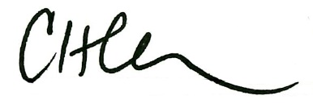
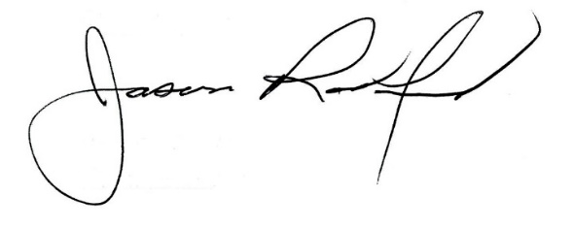

Carly Clem, Board Chair Jason Radford, Superintendent/Secretary

