ACTION ITEM A
February 24, 2024
OLDHAM COUNTY BOARD OF EDUCATION
CONCERN
Consider Emergency Approval of Policy Revisions and review of AP revisions.
DISCUSSION
Consider Emergency approval of policies that require approval with an emergency provision and review of AP updates/revisions as presented.
NUMBER | NAME OF POLICY | REASON FOR AMENDMENT/ADDITION
AB03.222 | Personnel | Emergency Approval - Holiday, Non-Working Days and Annual Leave was found to be incorrect. Approval for corrections
BU03.122 | Personnel | Emergency Approval: Certified Holidays and Annual Leave was found to be incorrect. Approval for corrections
C03.222 AP2 | Personnel | Documentation of Annual Leave Days
D03.122 AP.1 | Personnel | Documentation of Annual Leave Days
AD09.2242 AP.21 | Students | Authorization to Give Medication Parent/Guardian/Custodian
AK09.2241 AP.22 | Students | Student Medication Log
D09.21 AAP.21 | Students | Other Health Related Forms/Procedures
E09.224 AP.2 | Students | Emergency Medical Care Form
M09.213 AP.1 | Students | Communicable Disease/Bed Bug Guidelines
S09.213 AP.11 | Students | Prevention/Control of Head Lice in Schools
X09.2241 AP.23 | Students | Medication Administration Incident Report
 |  | OC Early Entrance Process and Procedure

RECOMMENDATION
Approve the emergency approval of policy and review of AP’s revisions as presented.

On a motion by _______________, seconded by _______________, the Board approved the emergency policy approval and review of AP updates as presented ( , )


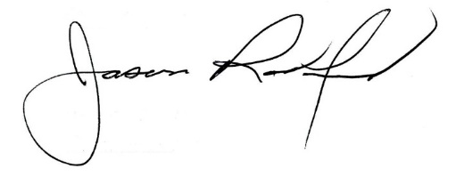

Carly Clem, Board Chair Jason Radford, Superintendent/Secretary

