CONSENT ITEM F
February 24, 2025
OLDHAM COUNTY BOARD OF EDUCATION
CONCERN
Consider Shortened School Day requests for OCS students.
DISCUSSION
The following students have requested a Shortened School Day. Details for each student follow this enclosure for your review.
STUDENT | SCHOOL
A.E. | NOMS
T.B. | OCMS
RECOMMENDATION
Post-approve the shortened school day request for these students.

On a motion by _______________, seconded by _______________, the Board post approved the Shortened School Day requests as submitted. ( , )


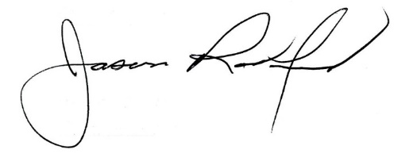

Carly Clem, Board Chair Jason Radford, Superintendent/Secretary

