CONSENT ITEM D
February 24, 2025
OLDHAM COUNTY BOARD OF EDUCATION
CONCERN
Consider Approval of Contracts in excess of $40,000 and donations in excess of $1000.
DISCUSSION
Pursuant to Board Policy 04.32, the Superintendent can approve contracts for transactions of less than $40,000 in value. Below are listed the name of the contract vendor, the subject of the contract, and the amount of the contract in excess of $40,000 that must be approved by the Board. Donations over $1000 must be approved by the board.
School/Dept |  | Vendor | Subject | Amount
OCHS |  | JAG | Grant for JAG specialist | $40,000.00-
DONATIONS
OCHS | Athletic Boosters |  | Football | $5,000.00
OCHS | Athletic Boosters |  | Wrestling | $2,776.33
NOHS | Athletic Boosters |  | No Restrictions | $1,766.79
EOMS | Booster Club |  | Uniforms | $3,000.00
EOMS | Booster Club |  | Uniforms | $3,000.00
SOHS | Nick Phelps |  | Boys Basketball | $1,500.00
Locust Grove | PTO |  | Technology | $14,892.78
RECOMMENDATION
Approved the attached contracts and donations and authorized the Superintendent and Secretary of the Board, or his designee, to execute all the above contracts, and ratified any contracts of these contracts signed prior to formal approval.

On a motion by _______________, seconded by _______________, the Board approved the attached contracts and authorized the Superintendent and Secretary of the Board, or his designee, to execute all of the above contracts for formal approval. ( , )

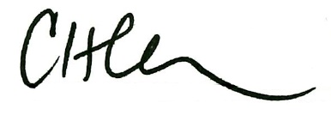
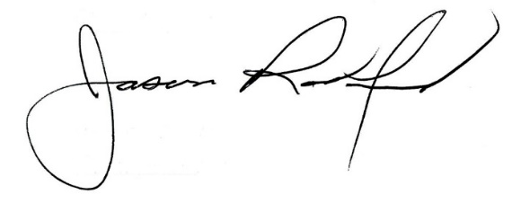

Carly Clem, Board Chair Jason Radford, Ed.D, Superintendent

