OLDHAM COUNTY BOARD OF EDUCATION
SPECIAL CALLED MEETING
January 22, 2025
Board Administrative Office
6165 W HWY 146
Crestwood, KY 40014
Attendance Taken at: 4:05 PM
Present Board Members:
Mrs. Suzanne Hundley
Mr. Adam Springer
Mr. Joe Dennis
Ms. Carly Clem
Ms. Allison Sheffer
The following individuals were also present at the meeting, Superintendent Dr. Jason Radford, Rudy Ellis, General Counsel, Eric Davis, Director of Student Services, Interim Deputy Superintendent Brent Deaves, and Oldham County Middle School Principal Tim Caldwell, Assistant Principal Jessica Grey.
- APPROVE AGENDA
The meeting was called to order at 4:05 p.m. Chairperson Hundley asked Superintendent Radford if there were any amendments to the agenda. Superintendent Radford indicated that there were no amendments to the agenda. On motion by Joe Dennis, seconded by Allison Sheffer, and unanimously carried, the Board approved the agenda (5-0).
- EXECUTIVE SESSION
Chairperson Hundley read the following statement: “At this time I need a motion to go into Executive Session to discuss a student personnel matter, pursuant to KRS 61.810(f). On motion by Joe Dennis , seconded by Allison Sheffer, and unanimously carried, the Board went into Executive Session at 4:07 p.m. (5-0).
- ADJOURN
Returning to open session at 5:19 p.m. and with no further business to discuss, acting on a recommendation from the superintendent, Chairperson Hundley called for a motion and second to adjourn. On motion by Allison Sheffer, seconded by Carly Clem, and unanimously carried, the Board adjourned the January 22, 2025, special called meeting at 5:20 p.m. (5-0)
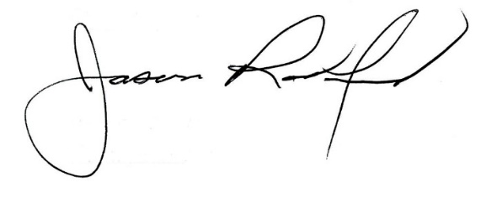
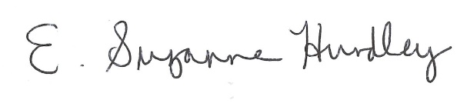

___________________________________ ______________________________
Suzanne Hundley, Board Chair Jason Radford, Superintendent/Secretary

