OLDHAM COUNTY BOARD OF EDUCATION
SPECIAL CALLED MEETING
February 11, 2025
Board Administrative Office
6165 W HWY 146
Crestwood, KY 40014
Attendance Taken at: 4:29 PM
Present Board Members:
Mrs. Suzanne Hundley
Mr. Adam Springer
Mr. Joe Dennis
Ms. Carly Clem
Ms. Allison Sheffer
The following individuals were also present at the meeting, Jason Radford, Superintendent, Interim Deputy Superintendent Brent Deaves, Rudy Ellis, General Counsel, Eric Davis, Director of Student Services.
- APPROVE AGENDA
The meeting was called to order at 4:30 p.m. Chairperson Clem asked Superintendent Radford if there were any amendments to the agenda. Superintendent Radford indicated that there were no amendments to the agenda. On motion by Joe Dennis, seconded by Allison Sheffer, the Board approved the agenda. (5-0).
- EXECUTIVE SESSION
Chairperson Clem read the following statement: “At this time I need a motion to go into Executive Session to discuss a student personnel matter, pursuant to KRS 61.810(f). On motion by Adam Springer , seconded by Joe Dennis, the Board went into Executive Session at 4:31 p.m. (5-0).
The board returned to regular session at 6:16 pm.
- ADJOURN
With no further business to discuss, acting on a recommendation from the Superintendent, Chairperson Clem called for a motion and second to adjourn. On motion by Allison Sheffer, seconded by Joe Dennis, and unanimously carried, the Board adjourned the January 30, 2025, special called meeting at 6.19 p.m. (5-0)


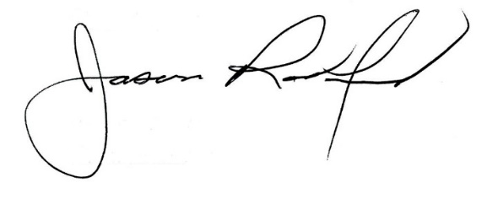

Carly Clem, Board Chair Jason Radford, Superintendent/Secretary

