OLDHAM COUNTY BOARD OF EDUCATION
SPECIAL CALLED MEETING
February 4, 2025
Oldham County District Office
6165 W HWY 146, Crestwood, KY 40014
Attendance Taken at: 4:30 PM
Present Board Members:
Mrs. Suzanne Hundley
Mr. Joe Dennis
Ms. Carly Clem
Ms. Allison Sheffer
Mr. Adam Springer
- CALL MEETING TO ORDER
Chairperson Clem called the meeting to order at 4:30 pm.
- APPROVE AGENDA
Motion Passed: Approval of the Agenda passed with a motion by Allison Sheffer, seconded by Suzanne Hundley. 5 Yeas - 0 Nays.
- EXECUTIVE SESSION
Motion Passed: Approval to enter into Executive Session @ 4:31 pm pursuant to KRS 61.810(1)(b) deliberations on the future acquisition or sale of real property by a public agency, but only when publicity would be likely to affect the value of a specific piece of property to be acquired for public use or sold by a public agency passed with a motion by Joe Dennis and a second by Suzanne Hundley. 5 Yeas - 0 Nays
The board returned to regular session at 5:18 pm and proceeded with the approved agenda.
- SUPERINTENDENT REPORTS
- Kelly Mrsic of Baird Financial presented an updated report on restricted funds.
- Brent Bohannon, Director of Facilities, updated the board on the Bid/Contract selection for the OCHS/BHS project.
- Kelly Mrsic of Baird Financial led discussion with the board on the bond sale procedure.
The board took all super reports under advisement.
- ACTION ITEMS
- Motion Passed: On a motion by Allison Sheffer, seconded by Suzanne Hundley, the Board approved the Award of special inspections contract for the BHS/OCHS Improvements project to Atlas Technical Consultants, LLC., 2724 River Green Circle, Louisville, KY 40206, and hereby authorize the Director of Facilities Management to execute the necessary documentation. (5,0)
- Motion Passed: On a motion by Suzanne Hundley, seconded by Allison Sheffer, the Board approved Award of a Contract for BHS/OCHS Improvements project to Marrillia Design and Construction, 794 Manchester Street, Lexington, KY 40508 for the lump sum amount of $40,173,929.00 and the revised BG-1 total project cost of $47,485,000 for submission to the Kentucky Department of Education, and hereby authorize the Director of Facilities Management to execute the necessary documentation. (5,0)

- Motion Passed: On a motion by Allison Sheffer, seconded by Suzanne Hundley, the Board approved the resolution authorizing the issuance of approximately $62,575,000 of General Obligation Bonds by the Oldham County School District to fund site and accessibility improvements at various elementary schools, stadium upgrades and improvements, and renovations and improvements at Oldham Co High School and Buckner High School (5.0)
- SUPERINTENDENT SEARCH PROCESS
Motion Passed: On a motion by Joe Dennis, seconded by Allison Sheffer, the Board approved the KSBA Timeline and Vacancy Ad as discussed with Don Martin of KSBA. (5.0).
- ADJOURN
With no further business to discuss, Chairperson Clem called for a motion and second to adjourn. On motion by Allison Sheffer, seconded by Joe Dennis, the Board adjourned the February 4, 2025, special called meeting at 7:14 p.m. 5 Yeas - 0 Nays

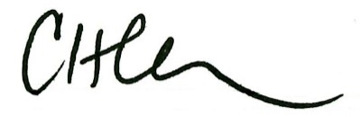
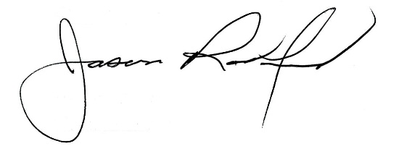

Carly Clem, Board Chair Jason Radford, Superintendent/Secretary

