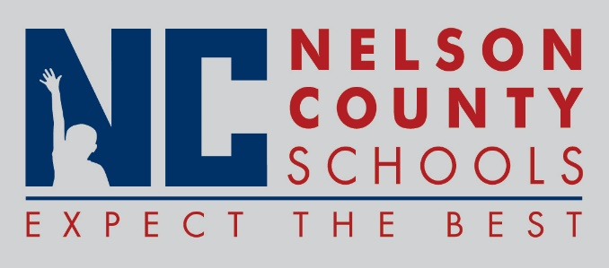

Information Paper
To: | Nelson County Board of Education
From: | Cheryl Pile, Director of State and Federal Programs
cc: | Tom Brown, Superintendent
Date: | April 17, 2018
Re: | Title 1 Parent Involvement Policy

Annual update of the Nelson County Schools Title 1 Parent Involvement Policy. Policy must be reviewed each year, no changes have been made.

