Dawson Springs Elementary School
Where the teachers and students give 100% every day and failure is not an option.
Panthers Prowling to Proficiency!

January 2024 Board Meeting
Elementary Principal Report
Jennifer Ward

- Academic Progress
  - iReady Fall to Winter comparison
    - Percentage of students at or above grade level
    - Lots of growth in math
    - Kindergarten had the largest amount of growth in reading with currently over 60% of our K students at or above grade level in reading.
    - 5th grade had the largest amount of growth in math
    - We are seeing that the iReady winter benchmark assessment is more rigorous than what the standards require the students to know at each grade level.
      - This is a good thing! The rigor is up!
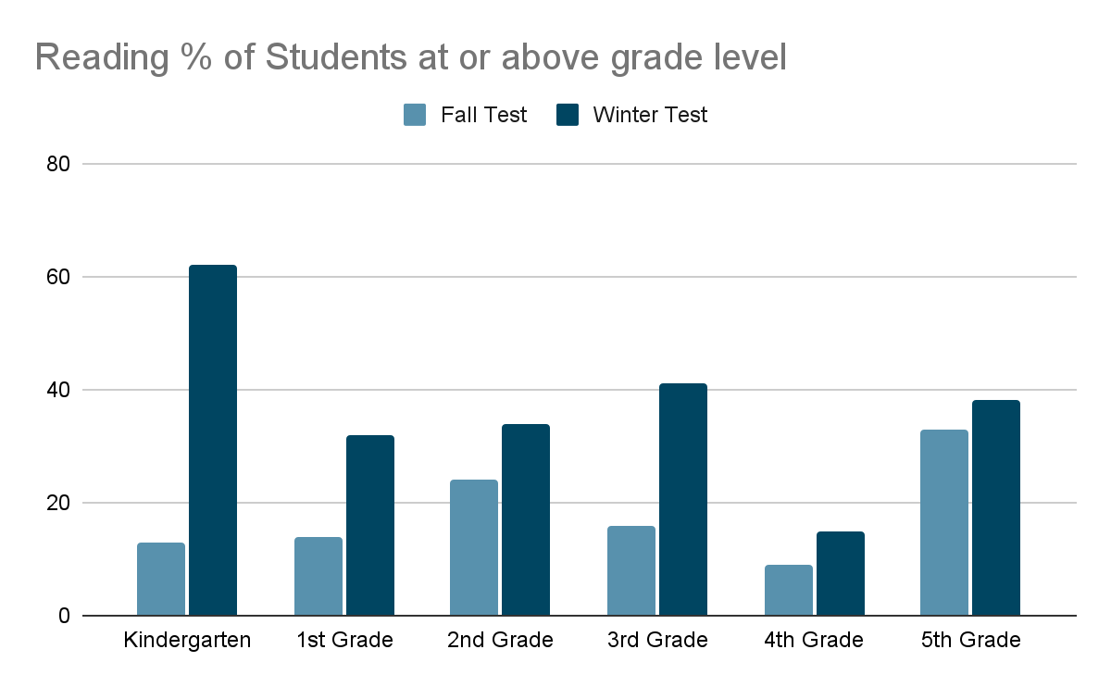
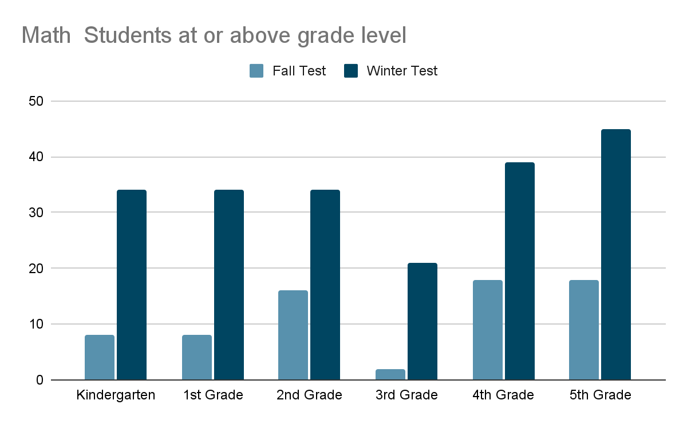

  - Reading comprehension across all grade levels
  - Math mastery
- PLC Conversations for the Month:
  - Assessment Protocol and Data Analysis Protocols
    - KSA formatted assessments and questions weekly
  - Reading comprehension is a focus for our students K-5.
  - Teaching math to mastery
  - Winter iReady diagnostic data compared to Fall looking at individual student growth
- Professional Development Information:
  - Classroom observations continue on a regular basis
  - Mid-year self reflections have been completed and compared to initial reflection for growth
    - Areas of need/concern are to be addressed with administrator
  - Mrs. Ward attended the KWEL Kentucky Women in Education Leadership conference this past week.
    - Sessions included information on the following topics:
      - Conflict resolution
      - Crucial leadership skills
      - Navigating conflicts confidently
      - More Assertive relationship-building skills
      - Mental wellness and well-being
      - Strategies to excel in leadership journey for resilience
      - Strengthen your leadership foundation
  - Helping teachers teach students “how” to read
  - Teaching math to mastery, not just exposure
  - K-2 focusing on number sense
  - 24/25 PD is already starting to be planned
- Upcoming Events:
  - 2/2/24 - Student of the month January grades 2-5
  - 2/2/24 - KSA Student Awards in the gym at 1:30 PM

