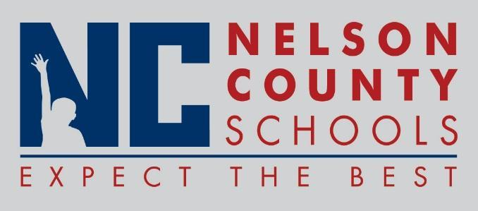

Decision Paper
To: | Nelson County Board of Education
From: | Tiffanie Clark, Director of Special Education
cc: | Wes Bradley, Superintendent
Date: | 7/17/18
Re: | Contract agreement with Dr. Amy Spriggs (Low Incidence Consultant)

RECOMMENDATION: Approve contract agreement with Dr. Amy Spriggs to provide consultation services to staff of low incidence classrooms.

RECOMMENDED MOTION: I move that the Nelson County Board of Education approve as presented.

