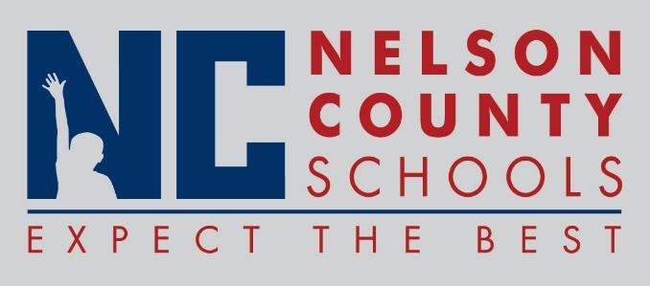

Decision Paper
To: | Nelson County Board of Education
From: | Chase Goff, Director of Leadership & Learning
cc: | Mr. Wes Bradley, Superintendent
Date: | July 17, 2018
Re: | Instructional Fees

RECOMMENDED MOTION: I move that the Nelson County Board of Education approve instructional fees as presented for the 2018-2019 school year.

