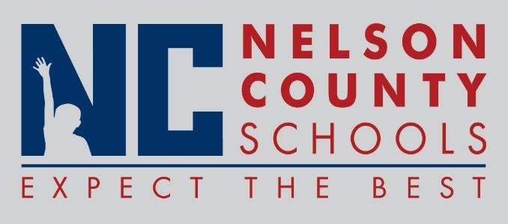

Decision Paper
To: | Nelson County Board of Education
From: | Mr. Wes Bradley, Superintendent
Date: | July 17, 2018
Re: | 2018-2019 Code of Acceptable Behavior and Discipline

RECOMMENDATION: Approve the Code of Acceptable Behavior and Discipline

RECOMMENDED MOTION: I move that the Nelson County Board of Education approve the 2018-2019 Code of Acceptable Behavior and Discipline

