NKY College & Career Connector
Report: September 2022
Upcoming WBL Opportunities for Students and Partners through NaviGo Scholars Collaborative Student Groups
- NaviGo Scholars flyers and applications-out to schools on September 1, 2022. Any student can apply at no cost to the student or the school. WBL occurs outside of the school day. Businesses will select the students. Student groups will begin to meet in October.
NaviGo Scholars Student Groups include:
- Nursing-St. Elizabeth
- Exploring Engineering-Mechanical, Civil, chemical, Electrical; Engineering Technologist, Electric Line Crew, Gas Operations, Solar Energy, Urban Planning- Duke Energy
- Cyber Security-US Bank
- Advanced Manufacturing & Engineering-Toyota
- Education (Pre-K to Post-Secondary)- Local Schools/Districts and post-secondary partners who are willing and able to participate as guest speakers, experts, etc. and Learning Grove
- Skilled Trades-Cutter Construction and Enzweiler Building Institute
- Business/Entrepreneurship- Community Partners and Learning Grove

Collaborative Efforts and Presentations:
- As schools are have returned to school-currently meeting with schools and districts to provide ongoing support in the area of post-secondary readiness and work-based learning opportunities individualized to meet school and district needs
- The CCC presented Keys information to 250 students at Ignite and additional information as requested by students
- Family engagement resources being shared with any schools as requested for all levels
- Providing additional support to employers to be ready to receive students for work-based learning
- Advanced Manufacturing Month-October 2022 (See attached flyer)
- The work-based learning continuum is being utilized to create tiered work-based learning opportunities for students

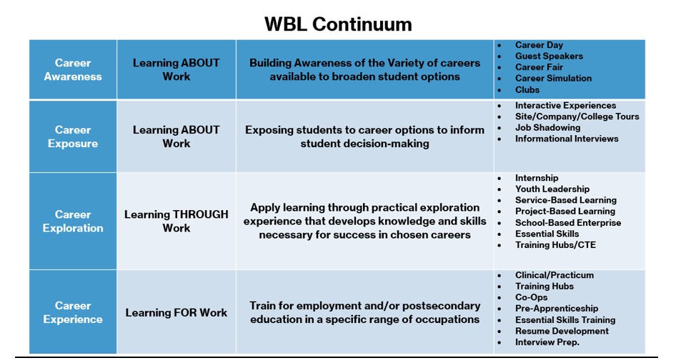

College & Career Counselor Network (CCCN), 2022-23
- The first College and Career Connector Meeting- September 13, 2022
- Monthly meetings will be in-person at the NKCES facility
- POC for NKCES will be Michelle Klein
- 90 min meetings will include the following:
  - Open Meeting
    - 20-30 mins for businesses and post-secondary providers to present
    - 10-15 mins for collaborative leads to present
  - Closed Meeting
    - Identified school to present on their WBL program
    - Breakout Session – networking/sharing best practices
    - Updates on upcoming WBL events

WBL Guides / Uniformed Approach
The Connector has put together user-friendly guides for the WBL opportunities, content is as follows:
- Rationale
- Benefits to business, school and student
- What to do before, during and after opportunity (for both school and business)
- Potential questions to ask/topics to cover, etc.
- School expectations
- Evaluations for both school/students and business
These have been well-received by businesses and will be introduced to schools at the first CCCN Meeting

MyCareerE3
The Connector has meet with some of the College & Career Counselors individually to get some feedback on MyCareerE3 and to hear what schools want from this platform, and from the Connector.
- We have looked at different ways schools can engage with the platform to make it more beneficial and valuable to both schools and students - these options are available for review and approval.
- We are also looking at presenting on this work to all-staff meetings at each school to foster a school-wide approach to WBL and encourage school-wide use of the platform

GROW NKY Pillar 2: College & Career Readiness
Working with GROW NKY’s Pillar 2, we have convened the collaborative leads for the local industry collaboratives (Supply Chain OKI, Health Collaborative, INTERalliance (I.T.), Allied Construction Industries, the Building Industry Association of NKY, and Advanced Manufacturing Industry Partnerships) to develop a uniformed approach to working with schools – common language and understanding, uniform documentation, etc.

NKY College & Career Connector, 2022-23
The main goal for the NKY College & Career Connector for 2022-23 is to ‘Close the Exposure Gap!”. As per the ‘YouScience Northern Kentucky Talent Report’, many of our students have high aptitudes for certain industries but little or no interest simply because they do not know what these careers entail. By exposing students to these industries and careers through company tours and job shadowing, they will be able to make much more informed college and career decisions, especially with alignment to their natural talents. The Connector will be diligently recruiting businesses to provide these opportunities to students.

