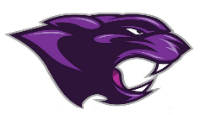

Board Meeting
December 2022

December 2022 Board Meeting
Jr/Sr. High School Principal

Basketball
- Boys team beat Caldwell Co. and recently won against Ft. Campbell

Clubs
- Clubs D meet (STLP, Future Educators, Yoga, Pep Club, and Student Council)

Academic Team
- Will be hosting the academic meet this year in January

Band Concert
- Held on the 11th

KSA Awards Day
- Students were awarded certificates for Proficient and Distinguished
- 18 Parking Signs were handed out to our top students

Rewards Day Trip
- Students went to Ice Skating and Lunch

Beta & National Honor’s Society
- Induction on the 1st

College & Career Ready
- We have less than three students not College & or Career Ready
- This class could be the first to have all students in College & Career Ready

