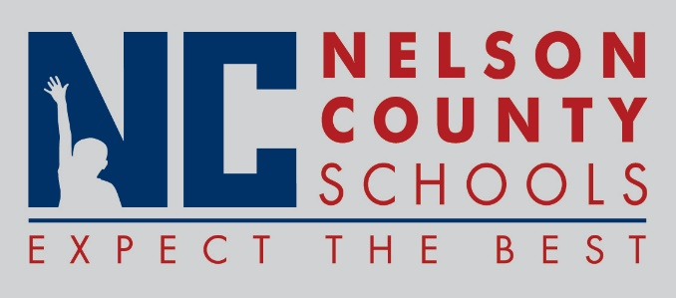

Decision Paper
To: | Nelson County Board of Education
From: | Kimberly Brown, Director of Secondary Education
cc: | Tom Brown, Superintendent
Date: | April 17, 2018
Re: | Perkins Grant 2018 – 2019 School Year

RECOMMENDATION: I recommend that the Nelson County Board of Education approve the 2018/2019 Perkins Grant to be utilized by High School Agriculture, Business and Family and Consumer Science Departments.

RECOMMENDED MOTION: I move that the Nelson County Board of Education approve the Perkins Grant for the 2018/2019 School Year in the amount of $ 31,220.00.

