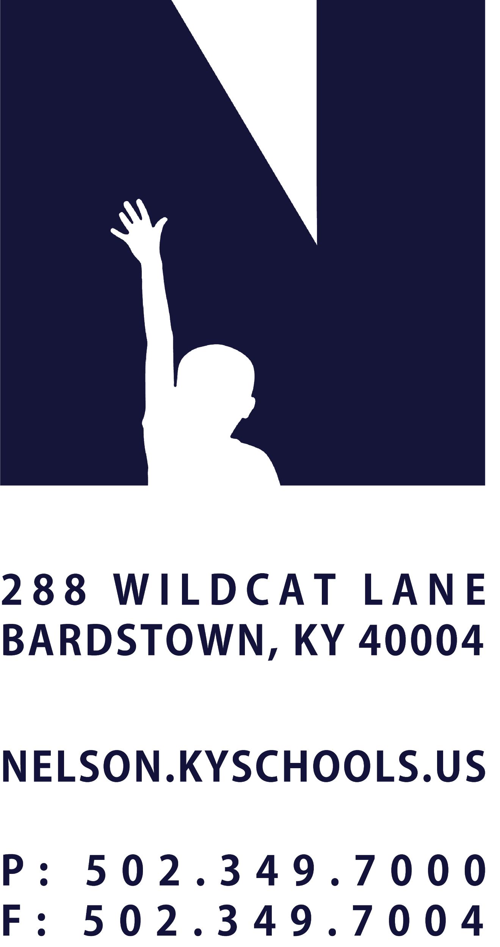 | JOB TITLE | COMMUNITY & SCHOOL MEDIA COORDINATOR
 | REPORTS TO | SUPERINTENDENT
 | SALARY SCHEDULE/GRADE | CLASSIFIED ADMIN, LEVEL II
 | CONTRACTED DAYS | 240 DAYS
 | EXEMPT STATUS | EXEMPT
 | JOB CLASS CODE | 7102
 | POSITION CLASSIFICATION | CLASSIFIED PROFESSIONAL
 | DATE APPROVED

QUALIFICATIONS
Bachelor’s Degree required.
Meaningful experience in communications, public relations, Journalism, or a related field.

POSITION SUMMARY
Work to energize our community through powerful district communications and initiatives that are efficiently and effectively shared with employees, students, families and the broader community.

DISTRICT AND SCHOOL PRIORITY ALIGNMENT
Align actions with district and school values and core priorities.
Evaluated based on the efficacy of aligned actions.

PERFORMANCE RESPONSIBILITIES
Develop and communicate the Nelson County PRIDE Brand in alignment with district vision.
Continually celebrate schools and the district to ignite Nelson County PRIDE.
Design, create and/or edit creative and consistent multi-media school system productions as needed for special media projects, television and/or web productions.
Provide technical direction for special media projects and television productions.
Ensure adherence to FCC rules and regulations.
Design, implement and maintain the district website, social media accounts and mobile applications while ensuring timely, accurate, essential and critical information is available consistent with District vision and branding.
Assist school and departments with the design, implementation and maintenance of their webpages while ensuring the web pages and content are consistent with District vision and branding.
Provide training to appropriate school and department personnel regarding the design, implementation and/or maintenance of school and department webpage.
Serve as the district spokesperson and maintains effective two-way communication between the district and its various publics to ensure:
  - dissemination of accurate, timely information about policies, programs, procedures, achievements, decisions and critical issues
  - interpretation of decisions and actions
  - coordination of programs and practices designed to provide an open climate which will elicit ideas, suggestions, and reactions from the community and employees alike
  - development of an effective working relationship with the media
Participate in community activities, network groups, and related professional organizations in order to keep abreast of ongoing and current issues in media relations.
Demonstrate a commitment to professional growth.
Demonstrate punctuality and regular attendance.
Maintain appropriate professional appearance.
Adhere to the appropriate code of ethics.
Perform other duties as assigned by Superintendent or designee.

KNOWLEDGE AND ABILITIES
Knowledgeable of technical operations of video cameras, video recording devices, audio equipment used with video production, lighting, electrical power sources, and the overall coordination required to use all the studio electronic equipment simultaneously to record and broadcast television programs or web programs.
Ability to manage the design, implementation, documentation, training and troubleshooting of all District web and social media resources.
Ability to operate a variety of multimedia equipment, design district and school system productions.
Ability to deliver consumer-ready materials for publication and/or broadcast within 24 hours of acquiring appropriate materials and/or footage.

PHYSICAL DEMANDS
Communicate effectively using speech, vision, and hearing.
Use of hands for simple grasping and fine manipulations.
Bending, squatting, reaching, with the ability to lift, carry, push or pull light weights.
Work is performed while standing, sitting and/or walking.
Bending, squatting, crawling, climbing, reaching. Requires the ability to lift, carry, push or pull light weights.
Requires indoor and outdoor activity.

