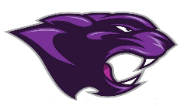

Board Meeting
December 2023

December 2023 Board Meeting
Jr/Sr. High School Principal

Clubs
- Clubs B meet (National Honor Society, FCA, Quiet Ball, FCCLA, and Photography)

Academic Team
- Ms. Rice it heading this up and they are practicing

Band Concert
- Held on the 10th

KSA Awards Day
- Students will be awarded certificates for Proficient and Distinguished
- 24 Parking Signs were handed out to our top students

Rewards Day Trip
- Students will be going Ice Skating and Lunch

College & Career Ready
- All seniors are College and Career Ready

PLC’s
- Have been meeting regularly

SBDM
- The CSIP has been completed and up to date and approved by SBDM

