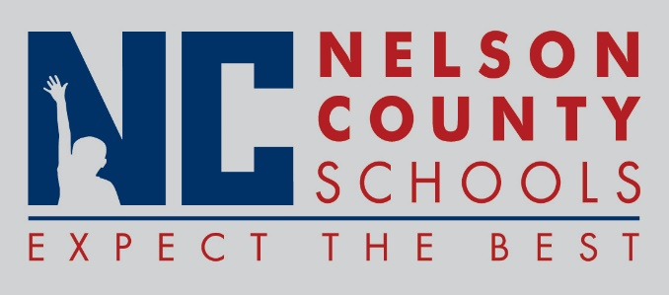

Decision Paper
To: | Nelson County Board of Education
From: | Mr. Wes Bradley, Superintendent
Date: | October 23, 2018
Re: | Board Training Approval
KSBA Fourth Regional Meeting, October 25, 2018
Elizabethtown High School
Board Member | Registration | Travel
Diane Berry | $25.00 | $27.26
Rebekah McGuire-Dye | $25.00 | $14.02
Jeff Dickerson | $25.00 | $19.91
Damon Jackey | $25.00 | $27.69

RECOMMENDATION: Approve request for Board member(s) to attend the KSBA Fourth Regional Meeting.

RECOMMENDED MOTION: I move that the Nelson County Board of Education approve request as presented.

