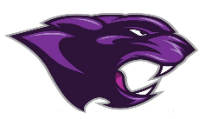

Board Meeting
November 2022

November 2021 Board Meeting
Jr/Sr. High School Principal

Basketball
- Moonlight Madness

Clubs
- Clubs B meet on the 4th ( NHS, FCA, Drama, FCCLA, and Student Newspaper)
- Clubs C meet on the 18th (Pep Club, Debate Club, Yoga Club, Student Ambassadors)

Academic Team
- JV Challenge competed on the 5th with one student placing in Arts & Humanities

Veterans Day
- Held on the 11th

Junior Beta Club Induction
- Held on the 15th

Jostens
- Handed out letterman jackets and class rings on the 17th

Rewards Day Trip
- Students went to Ice Skating and Lunch

Beta & National Honor’s Society
- Induction on the 1st of December

Home Coming on the 3rd of December
Band Concert on the 11th of December

