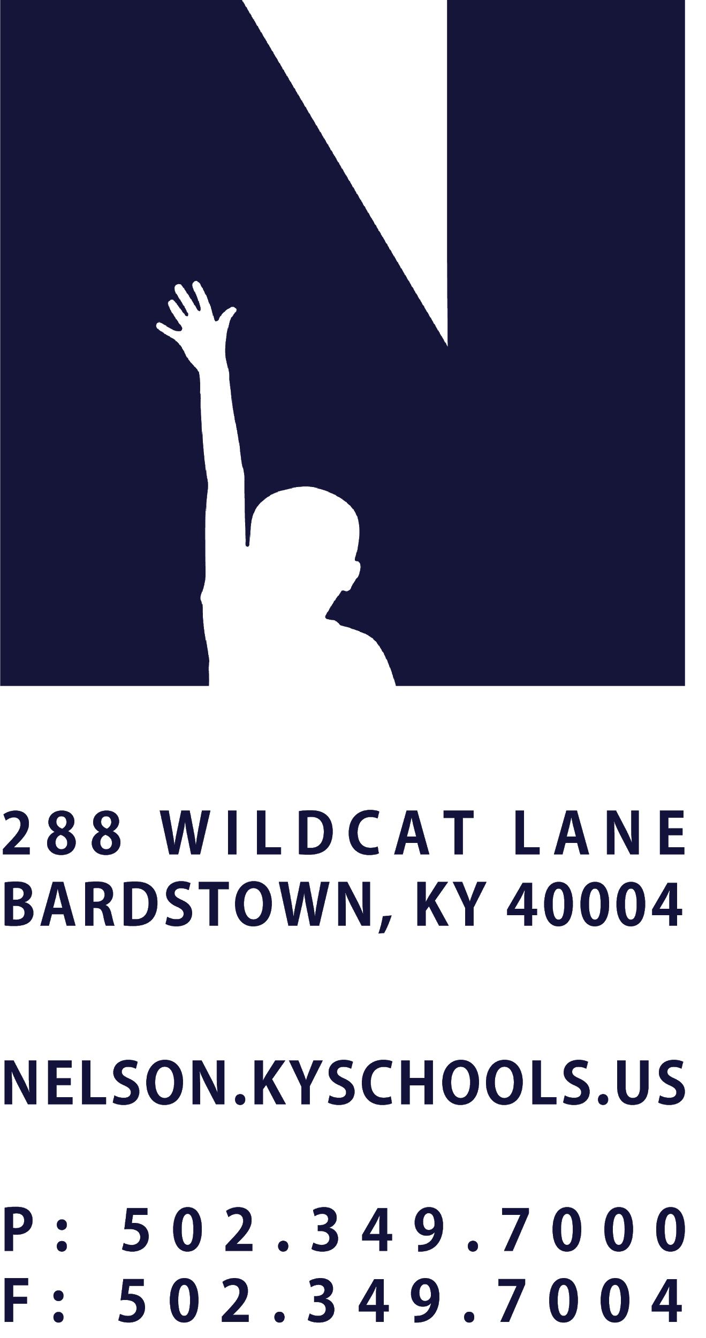 | JOB TITLE | STUDENT FACILITY ASSISTANT
 | REPORTS TO | FACILITY COORDINATOR
 | SALARY SCHEDULE/GRADE | FACILITY SERVICES
 | CONTRACTED DAYS AND/OR HOURS | AS NEEDED
 | EXEMPT STATUS | NON-EXEMPT
 | JOB CLASS CODE | 7788
 | POSITION CLASSIFICATION | STUDENT
 | DATE APPROVED

QUALIFICATIONS
Must be a student in Nelson County School District.
Must be 16 years old or older.

POSITION SUMMARY
Perform routine custodial and maintenance activities at an assigned school site or facility to maintain buildings, locker rooms and adjacent grounds areas in a clean, orderly and secure condition.

DISTRICT AND SCHOOL PRIORITY ALIGNMENT
Align actions with district and school values and core priorities.
Evaluated based on the efficacy of aligned actions.

PERFORMANCE RESPONSIBILITIES
Assist Facility Coordinator and other staff in performing custodial and light maintenance duties.
Sweep, scrub, mop, wax and polish floors and vacuum rugs and carpets in classrooms, offices, workshops and other assigned work areas.
Clean classrooms, restrooms, showers, locker rooms, shops, cafeteria, offices and related facilities as assigned; sweep, mop and clean gymnasium floor as assigned; spot mop spills and remove gum and debris. clean tables, chairs and floors after lunch periods as assigned.
Clean and disinfect drinking fountains, sinks, toilets, showers and urinals; clean mirrors, tile and windows.
Wash windows and walls; clean chalkboards, trays and erasers and empty pencil sharpeners.
Assemble, move and arrange furniture, supplies and equipment in preparing classrooms and multi-purpose rooms for special events or meetings.
Clean blinds, dust and polish furniture and woodwork and make minor, non-technical repairs as needed.
Pick up and rake paper, trash and debris around school grounds and in buildings; sweep and clean walkways and entrances.
Shovel, plow and salt sidewalks and steps as directed.
Participate on project crews during summer months for special cleaning assignments.
Demonstrates regular attendance and punctuality.
Adheres to the appropriate code of ethics.
Performs other duties as assigned by the Principal, Director of Maintenance and Grounds, or Superintendent.

KNOWLEDGE AND ABILITIES
Proper methods, materials, supplies, tools and equipment used in custodial work.
Modern cleaning methods including basic methods of cleaning and preserving floors, chalk boards, carpets, furniture, walls and fixtures.
Proper lifting techniques.
Determine appropriate action within clearly defined guidelines.
Work independently with little direction.
Basic computer skills.

PHYSICAL DEMANDS
Work is performed while sitting, standing and/or walking.
Requires the ability to communicate effectively using speech, vision and hearing.
Requires the use of hands for simple grasping and fine manipulations.
Requires bending, squatting, crawling, climbing, and reaching.
Requires the ability to lift, carry, push or pull items weighing up to 50 pounds.

