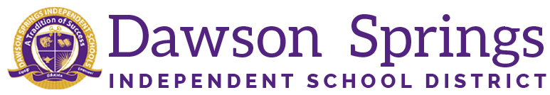

Dawson Springs Elementary School
Where the teachers and students give 100% every day and failure is not an option.
Panthers Prowling to Proficiency!

March 2024 Board Meeting
Elementary Principal Report
Jennifer Ward

- Academic Progress
  - Observations and Evaluations
    - Mrs. Ward has conducted the following observation/evaluations since the last board meeting:
      - 4 formal observations
      - 5 summative evaluations
      - 20 mini observations
  - Information gained from these observations:
    - 100% of the time the teachers had the I Can statements posted in the room and referenced them during the lesson.
      - Examples: I can model fractions greater than a whole on number lines. I can describe character traits, motivations, actions, and how they affect the plot. I can identify the lesson/moral of a story. I can determine the antonym of a word.
      - I can construct an explanation about why it rains a lot more over West Ferris than over East Ferris.
    - 80% of the time the learners were engaged in rigorous work in the classroom.
      - Very productive partner or small group work was observed that included lots of student to student conversations and discussions.
    - 75% of the time the instructional activity was direct instruction from the teacher.
      - There was 31% cooperative small group work, which needs to be increased.
      - As a whole, we need to increase our usage of TPTs again. Total participation techniques such as think/pair/shares, quick writes, numbered heads together, etc.
    - As far as differentiation is concerned, it was split half and half either very evident or not observed.
      - Differentiation is something that we are working on in the classrooms to meet the individual student needs while in whole group settings. Collaborative observations definitely include the differentiation, and it is very obvious, but at times, it is difficult to “OBSERVE” the differentiation because it is what is done on the back side of the lessons occurring in the room. Teacher use of student data to determine individual needs.
- PLC Conversations for the Month:
  - CSIP Progress Monitoring (two weeks for the process and data collection)
    - We have found the following information in regards to our CSIP goals and activities:
      - Students are engaged in grammar skills across all grade levels, but the process and resources used vary from grade level to grade level.
      - Our internal reading mastery coaches are still utilized in classrooms with new teachers and where additional coaching is needed. We need to edit this activity on the plan to reflect the new times we meet with staff.
      - We have also made note that our KSA mock assessment is listed as occurring twice per year. This activity will be edited to once per year.
        - KSA formatted assessments occur weekly.
      - Guided Reading activity needs to be edited to reflect grades K-2 using literature texts for Science and Social Studies content because it was listed as 3-5 grade.
    - Assessment and Data Analysis protocols are still being completed.
- Professional Development Information:
  - 24/25 PD is already starting to be planned
    - PBIS Tier 2 Training
    - Reading Comprehension
    - Teaching Math to Mastery
    - RTI
    - Rigor in all areas
- Upcoming Events:
  - 3/22 - March Student of the Month grades PK-1
  - 3/29 - March Student of the Month grades 2-5
  - 3/29 - DSES Club Day

