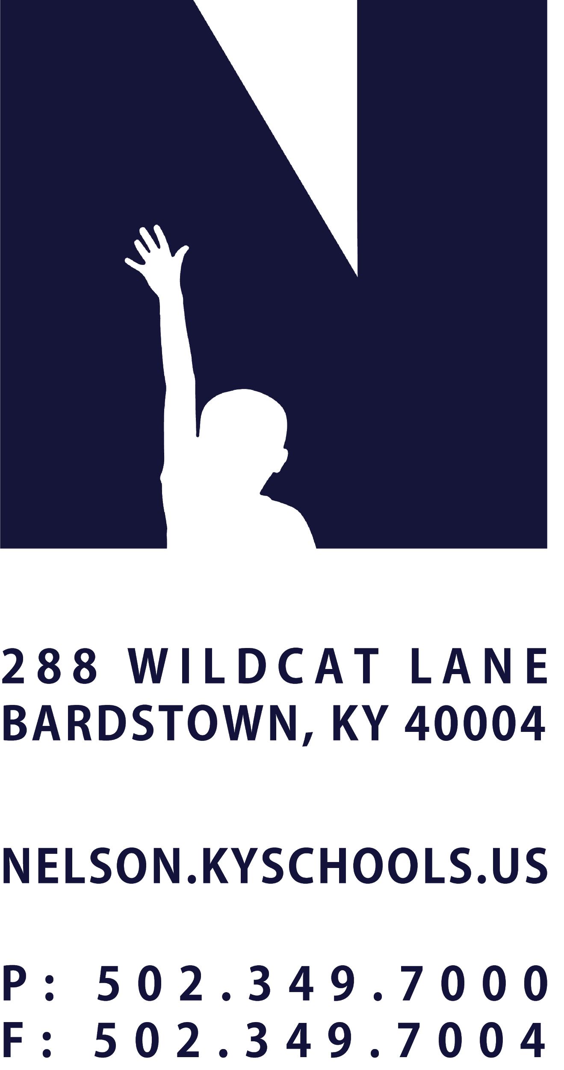 | JOB TITLE | CAFE COOK
 | REPORTS TO | CAFE MANAGER & DIRECTOR OF NUTRITION SERVICES
 | SALARY SCHEDULE/GRADE | NUTRITION SERVICES
 | CONTRACTED DAYS AND/OR HOURS | 180 DAYS, 4 OR 6 HOURS PER DAY
 | EXEMPT STATUS | NON-EXEMPT
 | JOB CLASS CODE | 7241
 | POSITION CLASSIFICATION | CLASSIFIED
 | DATE APPROVED

QUALIFICATIONS
Any combination equivalent to: high school diploma, G.E.D. Certificate or demonstrated progress toward obtaining a G.E.D. as required by Kentucky law.
One year of experience in preparing food in large quantities preferred.
Must complete a training course for certification of beginning food personnel as prescribed in 702 KAR 6:045.

POSITION SUMMARY
Prepare, cook, bake and serve a variety of foods in large quantities at an assigned school site; assist in other preparation duties as directed; maintain facilities in a clean and sanitary condition.

DISTRICT AND SCHOOL PRIORITY ALIGNMENT
Align actions with district and school values and core priorities.
Evaluated based on the efficacy of aligned actions.

PERFORMANCE RESPONSIBILITIES
Prepare rolls, biscuits, breads, cakes, cookies, and other baked goods in large quantities.
Prepare meat dishes, vegetables and other main dishes; prepare salads, sandwiches, fruit, soups, sauces, and other foods.
Assist in determining appropriate quantity of food items for preparations; adjust and extend recipes as needed; maintain food quality standards including appearance, and nutritional requirements.
Monitor temperatures of food to assure safety and quality standards are met; monitor water temperatures to assure proper temperature for sanitizing.
Serve food according to established guidelines and replenish serving containers as needed.
Clean cafeteria equipment, utensils, and appliances in compliance with kitchen sanitation and safety procedures and regulations; clean refrigerators and storerooms as required;
Utilize proper methods of handling foods while assisting in storing unused food and supplies; dispose of unusable leftovers.
Operate a variety of standard kitchen utensils and equipment, including slicer, chopper, mixer, steamer, dishwasher, electric warmer, range, oven, pressure cooker, cash register, dishwasher and other cafeteria equipment as required.
Record amounts of food sold and monies collected as assigned; assist with inventory and maintain routine records as directed; prepare records of foods cooked and foods leftover.
Prepare and bake foods for special events as needed; assist in banquets or special events as required.
Collect money and make correct change.
Contribute to a District culture of cafeteria caretaking.
Performs related duties as assigned by Cafeteria Manager, Director of Nutrition Services and/or Superintendent.

KNOWLEDGE AND ABILITIES
Principles and methods of quantity food service preparation, serving, and storage.
Sanitation and safety practices related to handling, cooking, baking, and serving food.
Health and safety regulations.
Basic computer, math, and cashiering skills.
Ability to operate and maintain standard machines and equipment found in school cafeterias and kitchens.
Ability to follow, adjust, and extend recipes.
Ability to communicate effectively both orally and in writing.
Ability to establish and maintain cooperative and effective working relationships with others.

PHYSICAL DEMANDS
Work is performed while sitting, standing and/or walking.
Requires the ability to communicate effectively using speech, vision and hearing.
Requires the use of hands for simple grasping and fine manipulations.
Requires bending, squatting, crawling, climbing, and reaching.
Requires the ability to lift, carry, push or pull items weighing up to 50 pounds.

