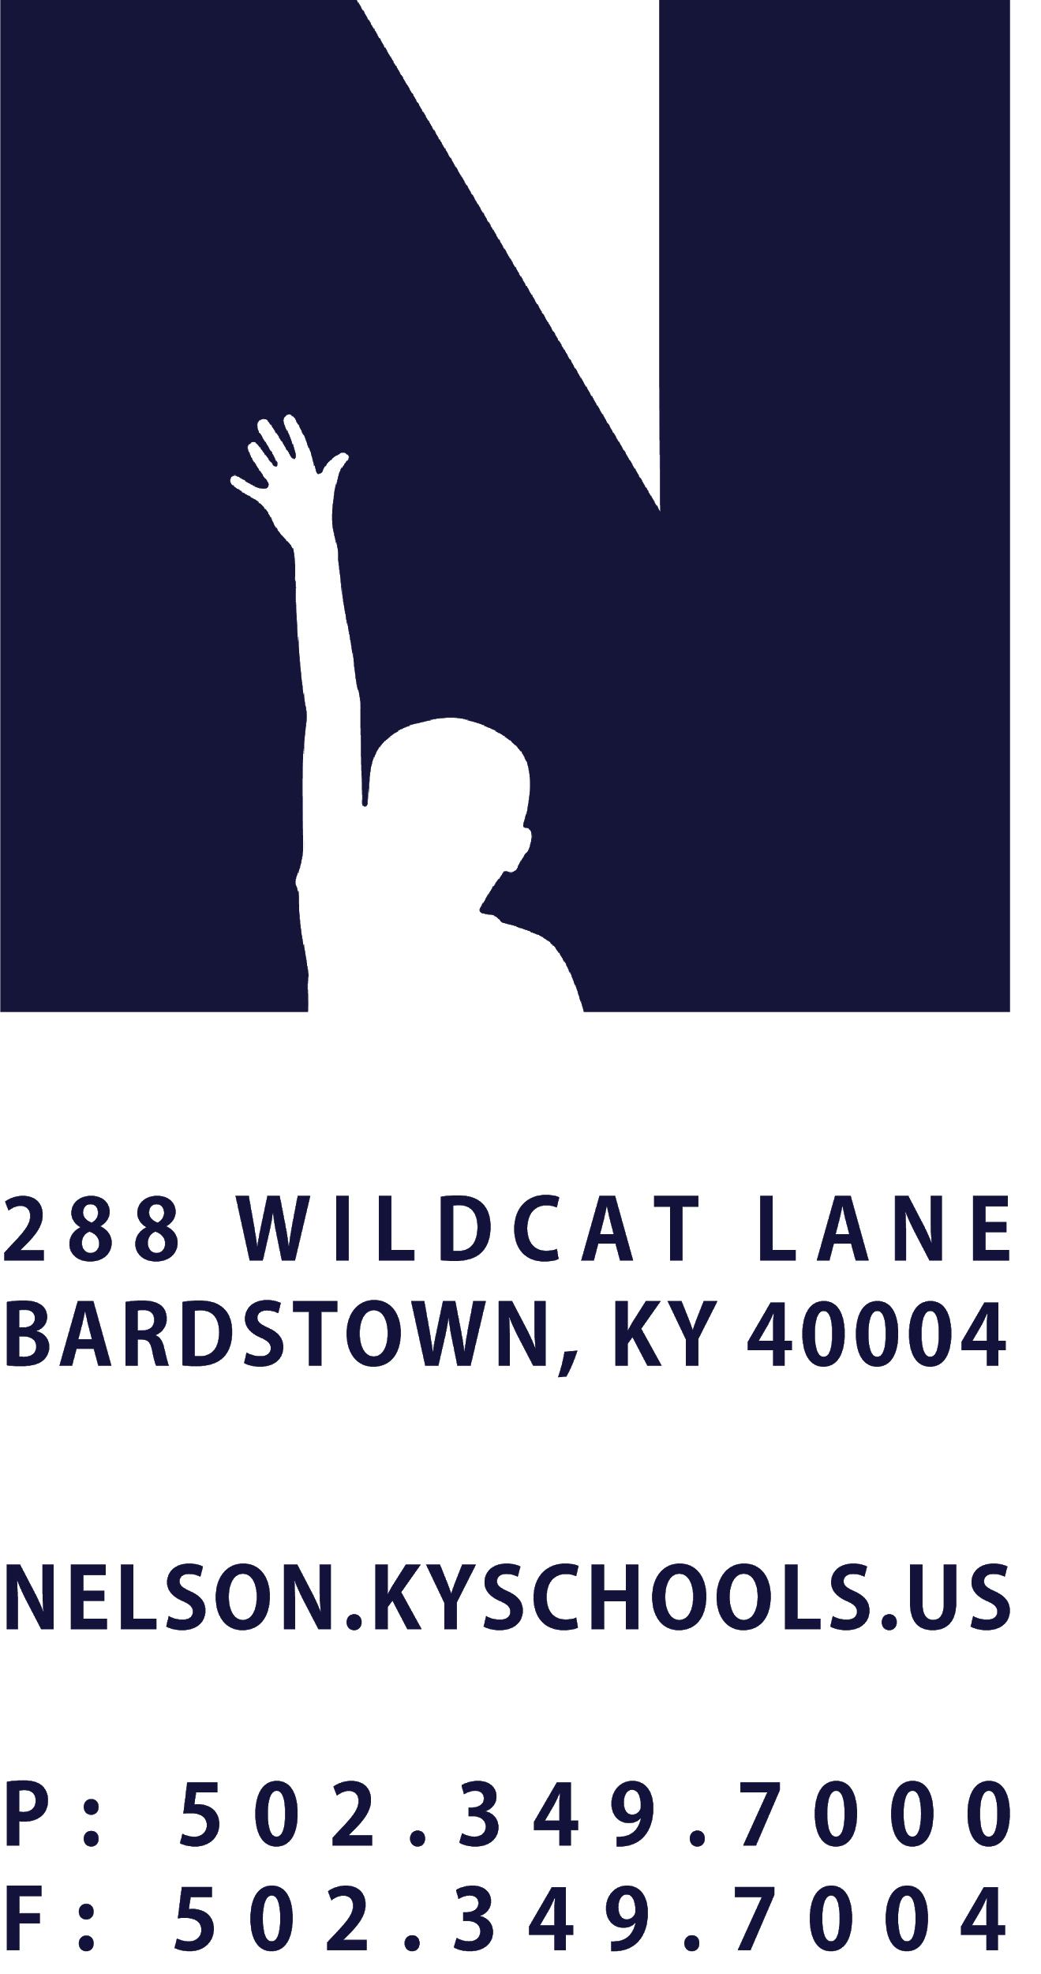 | JOB TITLE | CAFE MANAGER
 | REPORTS TO | DIRECTOR OF NUTRITION SERVICES
 | SALARY SCHEDULE/GRADE | NUTRITION SERVICES
 | CONTRACTED DAYS AND/OR HOURS | 181 DAYS, 7.5 HOURS PER DAY
 | EXEMPT STATUS | NON-EXEMPT
 | JOB CLASS CODE | 7212
 | POSITION CLASSIFICATION | CLASSIFIED
 | DATE APPROVED

QUALIFICATIONS
Any combination equivalent to: high school diploma, G.E.D. Certificate or demonstrated progress toward obtaining a G.E.D. as required by Kentucky law.
Two years of school nutrition experience preferred.
Must complete a training course for certification of beginning food personnel as prescribed in 702 KAR 6:045.

POSITION SUMMARY
Plan, coordinate, and manage a school district Nutrition Service program at an assigned location, ensuring cost effectiveness and compliance with District, State and Federal guidelines regarding nutrition, sanitation, safety and record-keeping; supervise and evaluate the performance of assigned personnel.

DISTRICT AND SCHOOL PRIORITY ALIGNMENT
Align actions with district and school values and core priorities.
Evaluated based on the efficacy of aligned actions.

PERFORMANCE RESPONSIBILITIES
Manage, coordinate, and oversee the day-to-day nutrition service operations at an assigned school site; analyze cost effectiveness, assure compliance with District, State and Federal laws, regulations and safety and sanitation procedures.
Prepare menus set by the Director of Nutrition Services, assuring nutrition and dietary balance.
Order food and supplies as needed each week; monitor and control expenditures.
Direct, assign, schedule, and evaluate assigned Nutrition Services personnel; assist the Director of Nutrition Services with reassignments, discipline or termination as appropriate.
Plan work schedules and coordinate daily work for efficient use of labor; receive calls from employees and call substitutes as necessary.
Assure accuracy of daily cash receipts; count and wrap money; prepare bank deposits; prepare daily report of meals served.
Train and assist employees in the proper handling of foods, correct use and care of equipment, and in maintaining high standards of sanitation and safety. Ensure all employees, substitutes, and student workers have completed KentuckyONE Training prior to or on the first day of work.
Inspect cafeteria and kitchen area daily to assure compliance with health, safety, and sanitation requirements and regulations.
Consult with school principal and Director of Nutrition Services to establish or revise operational policies; resolve problems involving food standards, labor costs, proper use of equipment and serving schedule.
Supervise and participate in food preparation and distribution to district students, staff and community members; plan and coordinate nutrition service operations with school activities to improve school and community relations and increase student participation.
Plan for catered events such as meetings, activities and parties, which utilize cafe facilities; compute costs of labor, supplies, and food; assign personnel and order food and supplies needed for event.

Maintain, prepare, and review a variety of nutrition service records and reports; review and approve employee time sheets weekly; prepare and review financial statements, operating reports, inventory, and cost control records.
Communicate with students, staff, parents, guardians, and outside organizations to exchange information, receive suggestions, and resolve issues related to the nutrition services department.
Attend meetings related to nutrition service operations and activities.
Lead Cafe Caretakers in accordance with District priorities; Create opportunities for team building; Participate in school and district events to create a culture of care.
Perform related duties as assigned by the Director of Nutrition Services and/or Superintendent.

KNOWLEDGE AND ABILITIES
Principles and methods of quantity food service preparation, serving, and storage.
Sanitation and safety practices related to handling, cooking, baking, and serving food.
Health and safety regulations.
Basic computer, math, and cashiering skills.
Ability to operate and maintain standard machines and equipment found in school cafeterias and kitchens.
Ability to follow, adjust, and extend recipes.
Ability to communicate effectively both orally and in writing.
Ability to establish and maintain cooperative and effective working relationships with others.

PHYSICAL DEMANDS
Work is performed while sitting, standing and/or walking.
Requires the ability to communicate effectively using speech, vision and hearing.
Requires the use of hands for simple grasping and fine manipulations.
Requires bending, squatting, crawling, climbing, and reaching.
Requires the ability to lift, carry, push or pull items weighing up to 50 pounds.

