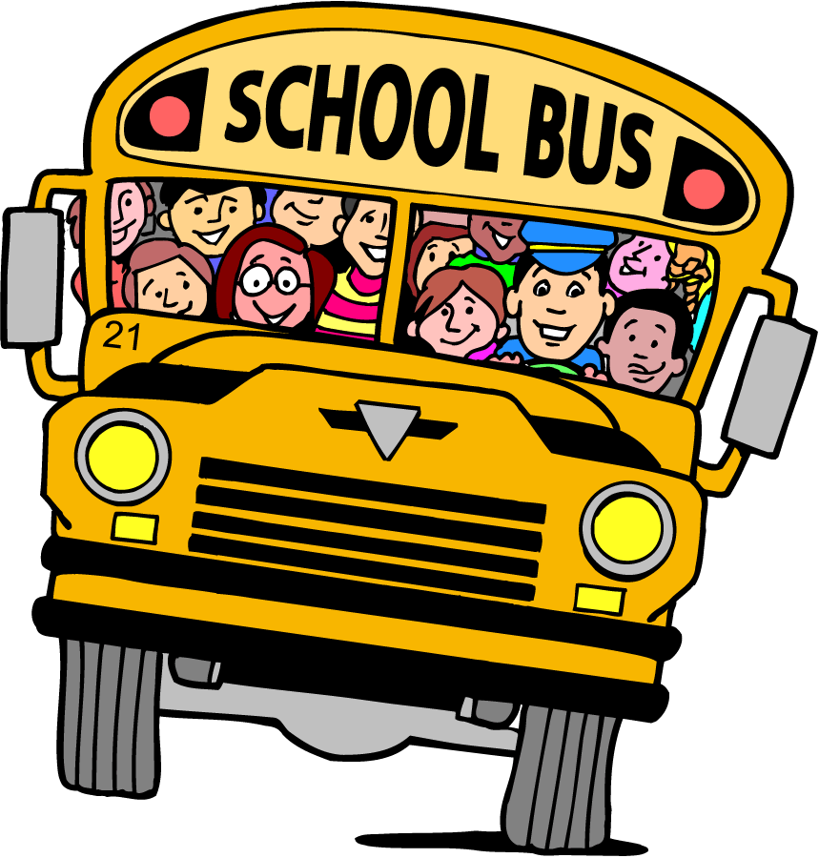
COMPANY TOUR

Company tours will help create interest and awareness of in demand careers like Supply Chain, Construction, Manufacturing, IT and Healthcare. We need to get more kids interested in these jobs after graduation and better prepare them for these careers. These tours will relate to the real world, and ideally include lessons before and after the tour to maximize the impact of the experience. Education, awareness, interest are keys to being able to work in an exciting industry such Supply Chain, Construction, Manufacturing and Healthcare. The students focus needs to be on continuing learning and utilizing tuition reimbursement to continue education while working and/co-op, apprenticeships and on-the-job training opportunities. This will give students a competitive edge and provide them for good paying jobs with careers after graduation.
The goal for each company tour is to introduce students to businesses, jobs and career opportunities. Further, provide direct contact with the people in the facilities, stimulating interest in a wide variety of jobs, careers and encouraging enrollment in the essential training / educational programs available.

THE BENEFITS OF A WORKPLACE TOUR?
BENEFITS FOR THE STUDENT:
- Students get a firsthand feel for what it’s like to work in the industry
- Students meet with professionals and gain real-world insights into jobs and careers
BENEFITS FOR THE EMPLOYER:
- Employers can nurture student interest in jobs and careers within their company and industry
- Employers can help students understand the education and skills they need for this industry
- Employers advance their reputation as supporters of education
BENEFITS FOR THE EMPLOYEE/PRESENTER:
- Employees can connect with local students and reflect on their careers and required skills
- Employees gain experience in public speaking and in serving as ambassadors for their companies
- Employees increase their job satisfaction after connecting with youth in their communities
PRE-TOUR - School

- Speak with the point-of-contact (POC) at the business to get an idea of what the students will see and do, how long the tour will likely take, who the students will meet and interact with, and what pre-requirements are necessary – I.D.s, close-toes shoes, PPE, use of cellphones, etc.
- Please note that some areas of the company may be off-limits to visitors due to environmental barriers, safety risks, and proprietary protection
- Ask the POC to prepare an orientation presentation that will be provided to students as they kick-off the tour – you may need to offer some guidance on this
- Work with the POC on making the tour exciting - students are magnetically attracted to loud, colorful, and exciting operations such as technology, automated picking systems, robotics, heavy equipment, manufacturing, live surgeries in healthcare, climbing into a heavy vehicle at a building site and boarding a cargo plane

PLANNING THE TOUR - School

- Determine who will go (students and staff), where, when, and how
- Determine duration of tour, including travel time
- Secure permission from school leadership
- Secure funding for transportation, expenses, etc.
- Book transportation
- Develop one-pager for parents/caregivers
- Allow 4 weeks to get permission slips, medical authorizations, and I.D.s in - where necessary
- Identify expectations and clearly relay to POC at the business
- Prepare the students for the tour by developing a lesson plan, presenting an industry-specific video followed by an open discussion - this is the perfect opportunity to tie in careers, career pathways, and the importance in demand careers like Supply Chain, Construction, Manufacturing, IT and Healthcare

TIPS FOR HOST – Business/College

- Please note that students may have to complete an assignment after the tour
- Allow the students time to put on the facility’s necessary PPE and explain why (OSHA)
- Break students up into small groups (if necessary) so they can hear and see
- Offer a short overview of the company: what it makes/does, how, why, who is the customer
- Have some videos, sample items and/or parts to show, and ask some questions about them
- Make the tour relevant to students - if the product or service is not something they personally use, identify an analogous product and/or explore who uses these products or services and why
- Ask questions about the product such as:
  - Could we make this out of another material, why or why not?
  - What effect would a change in size/tolerance have on the product?
- Explore the careers/pathways for this industry. What do workers do? What kind of education is needed? What subjects prepare student for theses careers? How much can you earn?
- Have staff address the group after the tour for a Q & A session (a panel of staff from various areas of the facility is best)
- Giveaways always popular
- Follow-up with the teacher to evaluate the event

DURING THE TOUR - School

- Keep students organized, together, and on their best behavior, adhering to health & safety rules
- Encourage students to stay focused and engaged, and to ask questions

POST TOUR - School

- Administer a Post-tour Survey (for students) immediately after the tour, (perhaps on the bus ride back to school)
- Send a ‘thank you’ note to the facility personnel along with a summary of the survey results (if used) Provide a follow up lesson where students reflect and expand on their experience.
- Follow up to see if the tour worked well for your host
- Make notes about what you would change for next time
- Publicize the tour in the district and/or community with stories and photos

- POST TOUR – Business

- Complete an evaluation / provide constructive feedback to the school
- Discuss (with your team) what worked best – determine best practices for school tours

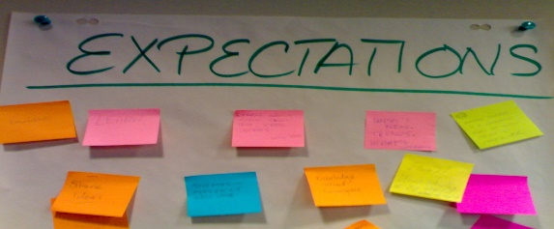
Company Tours – School Expectations
The company tour should:

- be intentionally Planned and Structured
- include an initial orientation/presentation
- include exposure to as many aspects of the facility as possible
- include speakers (during the actual tour) who have been prepped to talk to students about:
their role/title
their skills & qualifications
their career path – what subjects did they study in high school and/or college; did they complete an apprenticeship; what technical certifications do they hold; did they start out as entry level and work their way up; etc.
A typical day…
- include a Q & A session at the end with a panel – staff from different parts of the facility (to show students how the parts make up the whole – facility operations). The panel should be prepared to talk to students about the openings the company has, the earning potential, the benefits (such as tuition reimbursement), etc.

The company tour could include:

- lunch for students – an informal means for students and staff to interact
- company giveaways
- transportation assistance

COMPANY TOUR PLAN - School
School: |  | Business:
Purpose of Field Trip: | - To expose students to this industry sector - students will learn about the company, the different careers within this company, and the required skills and qualifications needed for success in these career fields and within this industry sector in general
Target Industry:
Grade(s):
Learning Objectives: | Students will:  - Identify possible career interests  - Become aware of skill requirements and career/training options  - Learn how to behave in a professional environment
School POC: |  | Business POC:
School Address: |  | Business Address:
Duration of Tour: |  | Transportation:
Travel Time: |  | Date of Tour:
Number of Students: |  | Number of Staff:
Leaving School: |  | Arrival Back at School:
Departure to Facility
Board Students & Teachers: |  | (Location) | (Time)
Return to School
Board Students & Teachers: |  | (Location) | (Time)
Issues/Comments:

Company Tour Checklist -School
(Allow at least 4 weeks to plan the tour)

Pre-Tour
Find your location
Talk with the POC at the business to inform of expectations and learn of theirs
Determine how many students will take the tour and how many chaperones are needed
Decide how much time you are going to use for your tour
Determine transportation costs involved
Determine lunch costs (if applicable)
Determine how you will fund your event
Determine PPE requirements
Determine inclusivity/accommodations for students with disabilities (if applicable)
Finalize the date and time for your event and make note of any facility requirements
Contact the transportation company you have selected to arrange
Compose a list of pertinent contact telephone number and email address
Get Parental Consent
Administer Pre-Tour Assignment

Tour Day
Ensure all students are appropriately dressed and are not carrying inappropriate devices
Ensure all students have the required documentation (I.D.s, etc.) where necessary
No food or drinks carried on the bus
Bring a list of student names (required by many facilities)
Bring a hard copy of the contact letter you prepared with your list of contacts
Bring student handouts (if applicable), student post tour surveys and don’t forget pencils & pens
Have PPE in place if required and if not provided by the company

Post Tour
Administer post-tour survey to students
Provide a follow-up lesson where students may reflect on their experience
Provide a press release with photos and/or story about your tour to your school’s web site
Send a thank you note and certificate of appreciation to appropriate facility personnel
Follow up to see if the tour worked well for your host
Make notes about what you would change for next time
Publicize the tour
Administer Post-Tour Assignment

Notes

PRE & POST TOUR ACTIVITY SHEET/ASSIGNMENT - School
Part A: Pre-Tour Questions and Activities
- What is the name of the company you will be visiting and where is it located?
- What industry sector(s) does this company fall under?
- What products do they make and/or what services do they provide?
- List three more companies in the NKY/Greater Cincinnati Area that also fall under this sector
- Research job opportunities within the company and find out about educational and skill requirements for the job
- Write 2 or 3 questions you would like to know about the company you are going to visit

Part B: Post-Tour Questions and Activities
- List the name of the company you visited and describe three jobs you saw employees perform in the company tour. What are the jobs you think are the most interesting?
- What did students learn about in demand jobs and careers? Were students aware of these careers prior to tours? What education programs will help students?
- Plan out the education and career pathway you would need to take from your current year in high school to being capable of working in one of the jobs you described in question number 1.
- What could you earn if you were working in the job/career you chose for question 3?
- What is the company doing for sustainability and to help protect the environment?
- Predict new products this company might have or variations to existing products.
- Do you see yourself in this career field? Why or why not?
- Search for a job opening in this sector and document the skills and qualifications the company is requiring
- What PPE were staff wearing throughout the facility?
- How diverse was the workforce regarding male/female, age (old/young) and race/ethnicity?
- What would you like to explore further relative to this company/industry sector?
- What colleges within the Greater Cincinnati area provide programs of study relative to this industry sector?

(Please feel free to use this space for general comments)

POST TOUR SURVEY – School

School: ______________________________________________________
Company: ______________________________________________________

Thank you for joining our tour today!
(Surveys are anonymous - you do not have to write your name on this survey)

We would like to know the following:

() Male Female Grade in School

Ethnicity: Asian Black Hispanic White Other

Instructions: Question 1) Is a short answer question
Please circle YES or NO for each statement (2-8) - read the statements carefully.

Industry Sector:
- What did you like most about this tour?
(Please write at least two sentences and use the back of this page if needed)

YES / NO 2) I was (already) considering a career in this industry sector before the tour

YES / NO 3) My teachers have talked about this industry sector with my class

YES / NO 4) Today I learned about technologies used in this industry sector

YES / NO 5) This tour gave me new information about careers in this industry sector

YES / NO 6) This tour helped me understand how school STEM subjects are used in industry

YES / NO 7) I would recommend that other students take this tour

YES / NO 8) After taking this tour I know a lot more about this industry sector

YES / NO 8) After taking this tour, I am considering a career in this industry sector

Please use the back of this page for any additional comments you wish to share
POST TOUR EVALUATION – Business
CONTACT NAME: ________________________________ TITLE: ___________________________
SITE ADDRESS: ________________________________________________________________________
PHONE: ____________________ EMAIL: _____________________________________________

Do you believe that the company tour was beneficial to the students? () ___Yes ___No
Please explain why?
_______________________________________________________________________________________________________________________________________________________________________________________________________________________________________________________________
What worked well / what did not?
_______________________________________________________________________________________________________________________________________________________________________________________________________________________________________________________________
Do you believe that the school should continue this effort to extend learning beyond the classroom? Why/why not? _______________________________________________________________________________________________________________________________________________________________________________________________________________________________________________________________
How did the students demonstrate that they came well-prepared for the tour? _______________________________________________________________________________________________________________________________________________________________________________________________________________________________________________________________
Do you have any suggestions or comments to make the experience more valuable to the students? _______________________________________________________________________________________________________________________________________________________________________________________________________________________________________________________________
Are you willing to participate in similar experience in the future? () ___Yes ___No
If not, why not?
__________________________________________________________________________________________________________________________________________________________________________
Your willingness to open your doors and provide a worthwhile exploratory experience is greatly appreciated and will help our region in addressing the Exposure Gap that many of our students face. The partnership between schools, businesses and community agencies is vital to better preparing our youth for the jobs of tomorrow. ‘Thank-You’ for your help!

