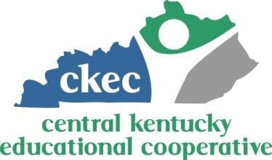

CKEC Mini-Grant Proposal Application
Due Date: June 1, 2018
Name of the School District:___Nelson County_____ Date:___5/18/18________
Using KDE Required Scope of Work (see attachment) provide a brief description of the grant proposal:

Indicator 17- State Systemic Improvement Plan
In order to increase achievement in students with disabilities, evidence based instruction and curriculum is necessary. Through this grant, Math-U-See manipulatives, student & teacher materials, and training would be purchased. From there, teachers would implement the evidence based curriculum to expose students to additional material and various styles of learning in order to decrease the current learning gap. Teachers would be provided training to implement the curriculum to achieve the greatest success possible. The curriculum supports current content being taught in the regular education classroom and assist in teaching mastery.
Currently, there are 31 students identified in special education. New Haven special education students scored 100% in the Novice and Apprentice category in math on the 2016-2017 KPREP assessment. Additionally, 85% scored in the bottom two quartiles on the MAP math assessment in spring of 2018.

The District will be purchasing the materials that will go with the training and overage from the accepted mini-grant.

Expected Budget (not to exceed $1500)
Item | Estimated Cost
Professional Development/Teacher Modules | $ 1,700.00 (grant covers ($1,500)
Total | $ 1,700.00 (grant covers $1,500)

*Can be items already purchased (as long as it meets the components under the Scope of Work). Submit documents such as invoices, POs etc.

Signature of DoSE:__________________________________ Date:___________________________

