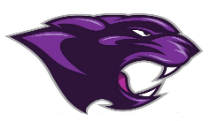

Board Meeting
October 2022

October 2022 Board Meeting
Jr/Sr. High School Principal

State Test Scores
- High School still performing better than area high schools around us.
- Middle School still has some improvements to make

Fall Festival
- Held on the 14th with a great turnout

Clayton Q
- Performance at High School for a PTO fundraiser

Window Painting
- Held on the 21st

Report Cards
- End of the nine week and report cards went home with students

Beta Induction
- November 2nd at 6:00 pm

Golf team
- Gage Smiley competed in the State Golf Tournament.

Student of the Month/Athlete of the Month
- Back to doing this

